E-Commerce Reinvented

A Future Built on Connection

2025 REPORT

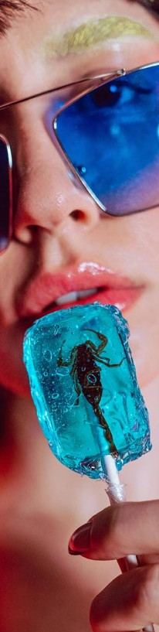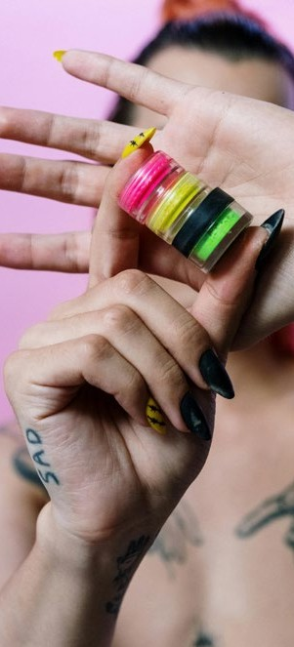

###### How TikTok Shop is reshaping how, why and where we buy

TIKTOK SHOP x WGSN E-COMMERCE REINVENTED 02

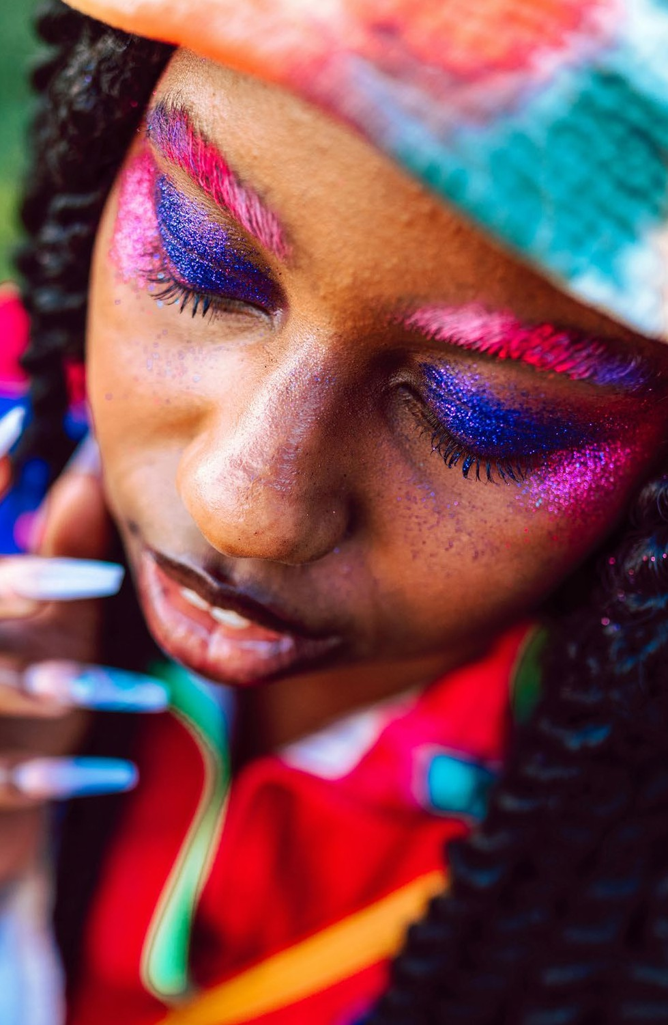

#GRWM



1. **#FYP (For Your People):** Commerce as Community

###### **POV:** Redefining Discovery Commerce

1. **#TikTokMadeMeBuyIt:** E-commerce and Shopper Shifts **04 Do It For The Trend:** Trends and Opportunities for 2025 **05 From Views to Buys:** Leverage the Best of TikTok Shop

Pexels

 SECTION 1: #FYP

#FYP

#### (For Your People) Commerce as Community



E-COMMERCE REINVENTED 03

In today’s hyper-connected world, people are seeking experiences that bring them closer to others. In fact, [78%](https://sproutsocial.com/insights/data/social-media-connection/#%3A~%3Atext%3DOf%20all%20the%20communication%20channels%2CSection%203) of consumers believe brands on social media have the power to foster connection and community. TikTok Shop taps into this desire by transforming shopping into a vibrant, shared

experience fueled by discovery, creativity, and entertainment.

Whether through the buzz of livestream shopping, the authenticity of user-generated content, or influencer-led storytelling, TikTok Shop turns transactions into celebrations. It’s a space where people come together to share recommendations, explore trends, and engage in real-time interactions that go beyond just buying products.

By embracing its social DNA, TikTok Shop reminds us that success isn’t just about selling—it’s about creating experiences that spark joy, build connections, and foster a sense of belonging among its audience.

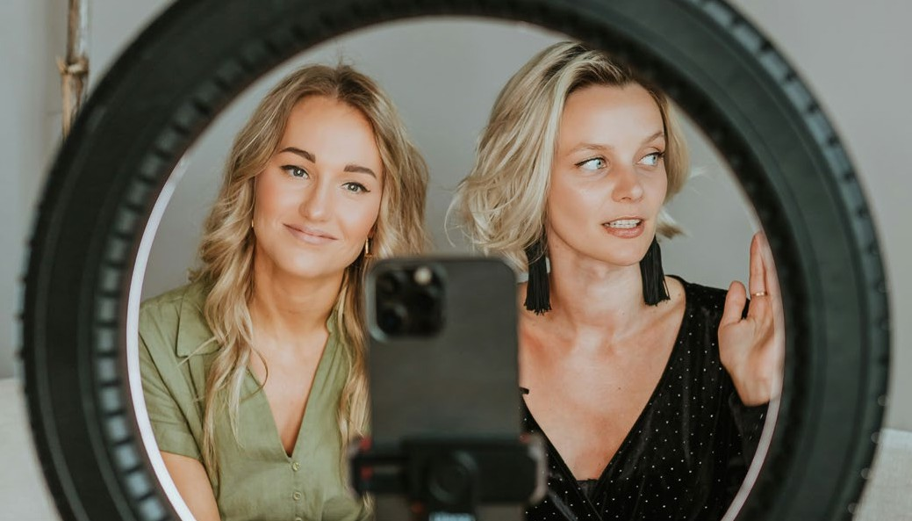

Unsplash



 SECTION 2: POV E-COMMERCE REINVENTED 04

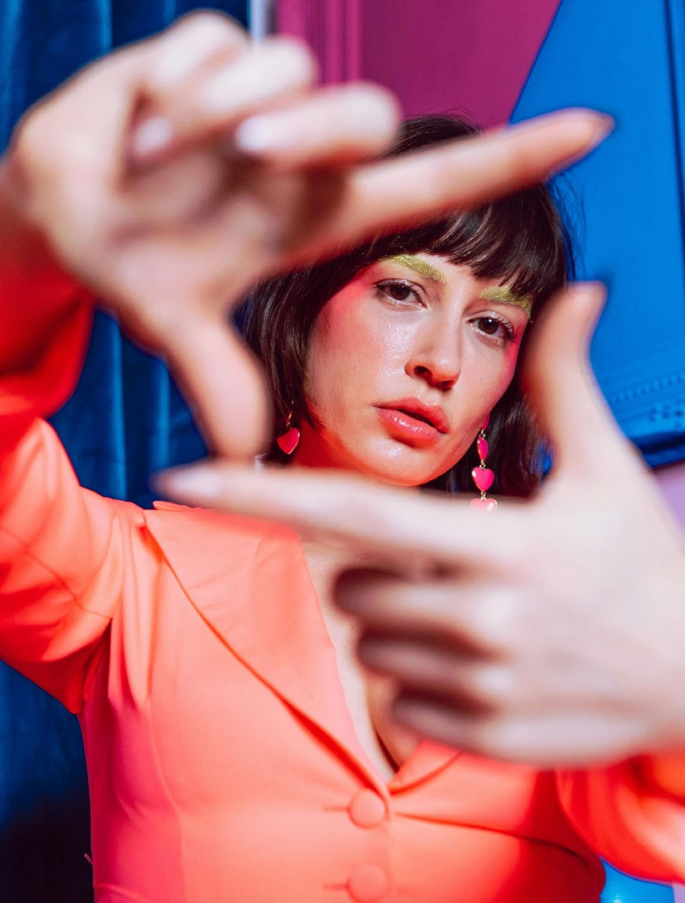

POV

#### Redefining Discovery Commerce



Pexels

 SECTION 2: POV E-COMMERCE REINVENTED 05

#### The Era of TikTok Shop



The discovery commerce industry in the UK is predicted to more than double in the next four years, rising from

£7.4 billion to almost £16 billion by 2028.

Since its launch, TikTok Shop has redefined how people connect, create, and shop on social media.

Powered by showing people more of what they love, TikTok’s short-form video magic has turned the platform into a global hub for creativity, from the early days of viral dance trends to niche content.

TikTok Shop takes this cultural influence to the next level, transforming scrolling into shopping. With over 200,000 UK sellers onboard and a 131% year-on-

year increase in the number of people shopping on the platform, the in-app e-commerce feature lets users discover, review, and purchase products seamlessly, making it the ultimate destination for businesses to tap into viral trends and reach diverse audiences in real time.

16bn



Deathtostock

7.4bn

TikTok, [2024](https://newsroom.tiktok.com/en-gb/retail-economics-report)

 SECTION 2: POV E-COMMERCE REINVENTED 06

TikTok Shop blends the discovery power of social media with the ease of e-commerce, connecting brands with buyers at their peak moments of inspiration.

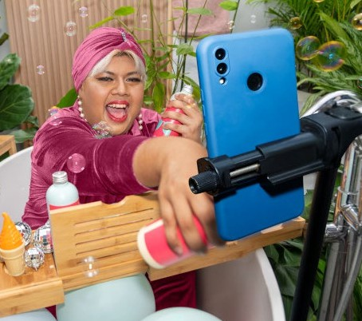

TikTok Shop

Its tools help businesses turn high engagement into instant conversions, transforming curious scrollers into loyal customers with just a few clicks.

By breaking down barriers between content and commerce, TikTok Shop revolutionizes the user journey, integrating discovery, reviews, and purchases into one seamless experience. For brands, it’s a gateway to reach engaged audiences, tap into subcultures, and drive sales through authentic creator partnerships.

With its ability to spark loyalty and capitalize on trends, TikTok Shop offers a game-changing platform for innovation and growth. In the following sections, explore the key e-commerce trends shaping 2025 and beyond—and learn how TikTok Shop can unlock your brand’s potential.

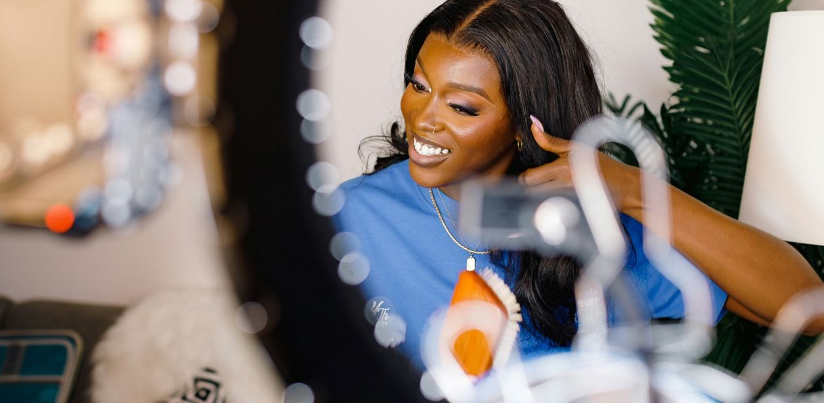



Unsplash

TikTok users lead the way in discovery commerce penetration, with

%

44

having made a purchase directly on TikTok, and one in four purchasing on the platform at least once a month.

TikTok, [2024](https://newsroom.tiktok.com/en-gb/retail-economics-report)

 SECTION 3: #TIKTOKMADEMEBUYIT E-COMMERCE REINVENTED 07

# #TikTokMadeMeBuyIt

#### E-commerce And Shopper Shifts

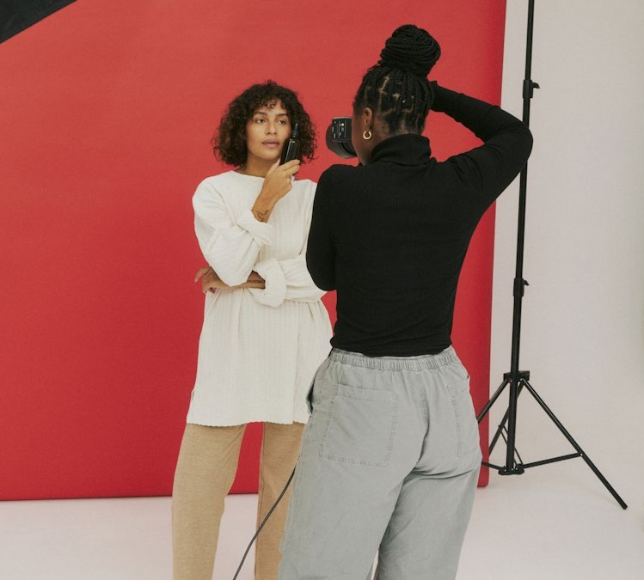

Deathtostock



 SECTION 3: #TIKTOKMADEMEBUYIT E-COMMERCE REINVENTED 08

#### E-commerce & Shopper Shifts

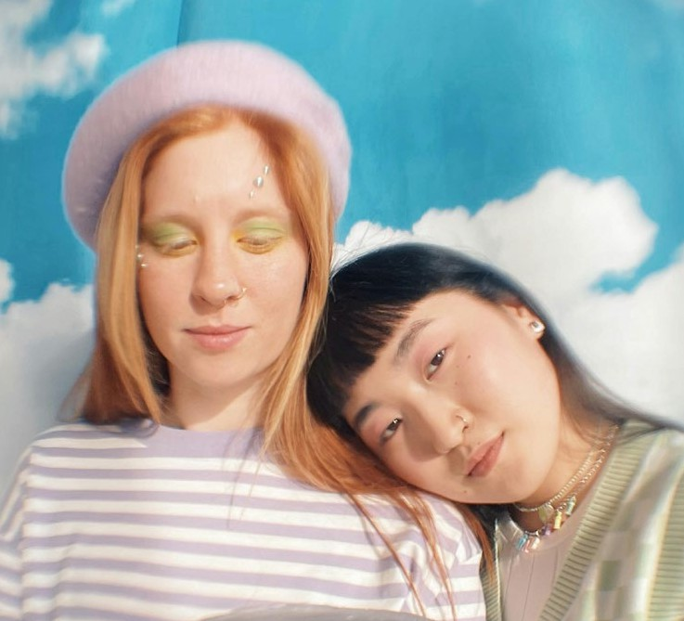

Pexels

02



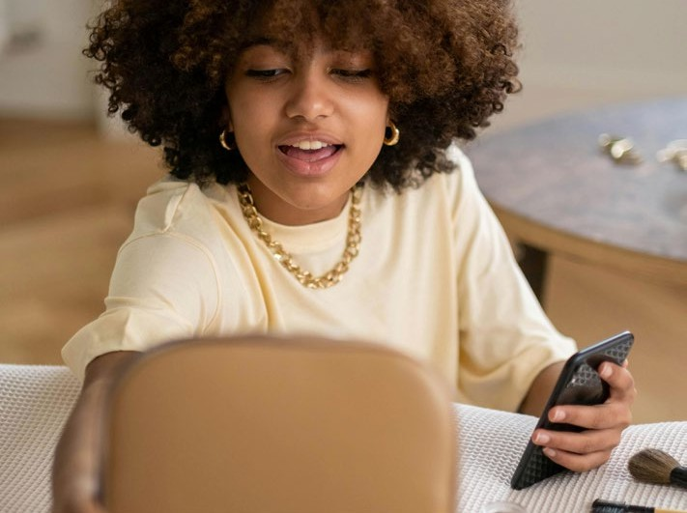

Pexels

01

1. From Shopping to Entertainment

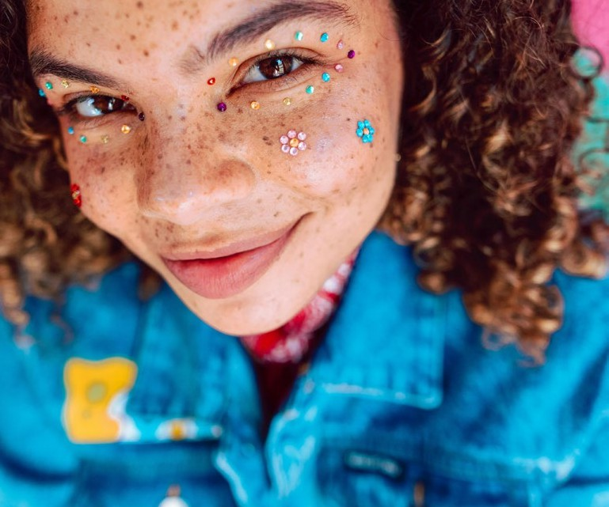

Pexels

03

1. The Creator Connection
2. Jumping on the Trend Cycle

 SECTION 3: #TIKTOKMADEMEBUYIT

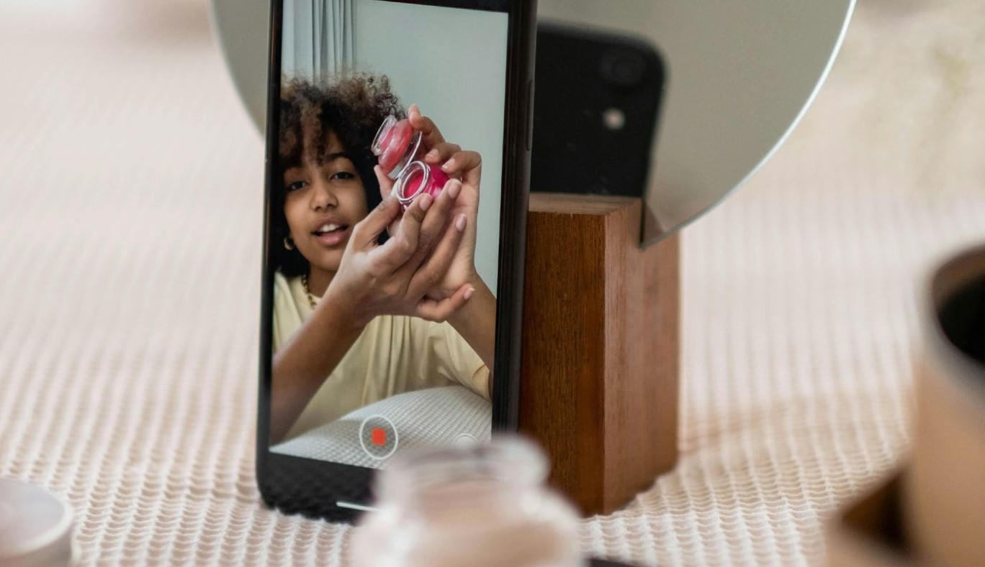

Pexels

E-COMMERCE REINVENTED

09

01 FROM SHOPPING TO ENTERTAINMENT

##### The Rise of Livestreaming

Live commerce is all about connection:

Unlike the home shopping TV days, today’s livestreams turn shopping into a social experience packed with two-way instant interaction, shared excitement, and relatable stories. An evolution of traditional e-commerce, live commerce meets emotional and social needs, creating moments that foster human connection while making shopping feel communal and engaging.

With conversion rates up to [10x higher](https://www.mckinsey.com/capabilities/growth-marketing-and-sales/our-insights/ready-for-prime-time-the-state-of-live-commerce) than conventional e-commerce and projected to make up [10–20%](https://www.mckinsey.com/capabilities/mckinsey-digital/our-insights/its-showtime-how-live-commerce-is-transforming-the-shopping-experience) of global e-commerce sales by 2026, live commerce is a game-changer. As consumers look to their phones for inspiration and advice, livestreaming bridges content and commerce, giving brands a unique opportunity to deepen their connection with online communities.

In this era of hyper-niche digital culture, success isn’t just about deals—it’s about creating spaces for entertainment, interaction, and belonging. By tapping into the fun and immediacy of live commerce, brands can build loyal audiences and keep their communities engaged in an increasingly fragmented digital landscape.

Gen Z consumers are leading the way in social commerce, with

47%

[of consumers having made a livestream](https://theinfluencermarketingfactory.com/wp-content/uploads/2022/11/livestream-shopping-report.pdf)

[purchase in both the US and UK.](https://theinfluencermarketingfactory.com/wp-content/uploads/2022/11/livestream-shopping-report.pdf)



Emplifi, 2023

 SECTION 3: #TIKTOKMADEMEBUYIT E-COMMERCE REINVENTED 10

THE RISE OF LIVESTREAMING

01 FROM SHOPPING TO ENTERTAINMENT



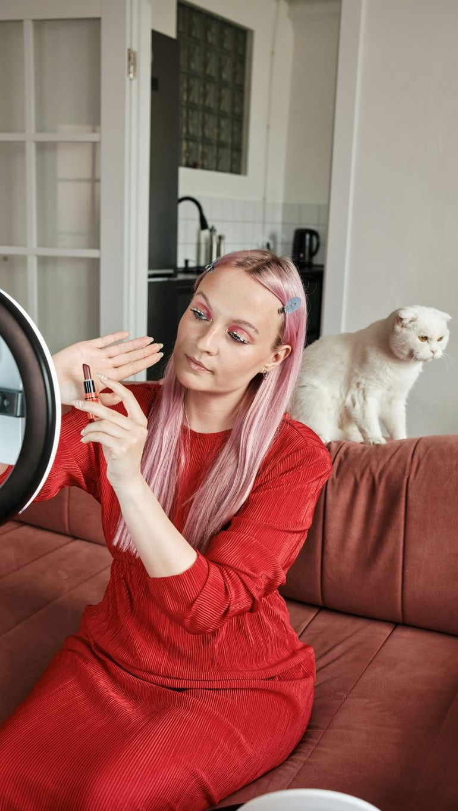

TikTok Shop

With TikTok’s explosive growth, live commerce has found its perfect stage. With TikTok Shop, it surged beyond just being a hotspot for viral content—**it’s a thriving live commerce hub, revolutionizing real-time brand engagement.**

Livestreaming on TikTok Shop lets brands go live to showcase products, answer questions, and connect directly with viewers—all while customers shop without ever leaving the app. This seamless integration of content and commerce creates a scroll-stopping ecosystem that makes users keep coming back for more.

Smart brands are turning TikTok Shop into a live-action showroom, using storytelling, Q&As, real-time demos, and even live customer feedback to make products pop. This real-time interaction builds trust, entertains audiences, and turns followers into loyal customers, proving that live commerce is the ultimate conversion engine.



Live videos is the most used feature for audience engagement, at 33.5%, with

%

30

of marketers using it

for direct sales.

Influencer Marketing Hub, [2024](https://influencermarketinghub.com/tiktok-marketing-report/)

1 beauty product every

2

## seconds

Beauty brands across the platform are capitalising on

this combination of community, shopping and entertainment, with a beauty product sold every two seconds on Shop and Made By Mitchell selling $1 million in 24hrs on LIVE just last month, making the beauty category one of the most successful across TikTok Shop.

Emily Caine, Head of Beauty at TikTok, [2024](https://theindustry.beauty/p-louise-breaks-records-as-it-sells-2-million-in-12-hour-live-on-tiktok-shop/)

SECTION 3: #TIKTOKMADEMEBUYIT E-COMMERCE REINVENTED 11

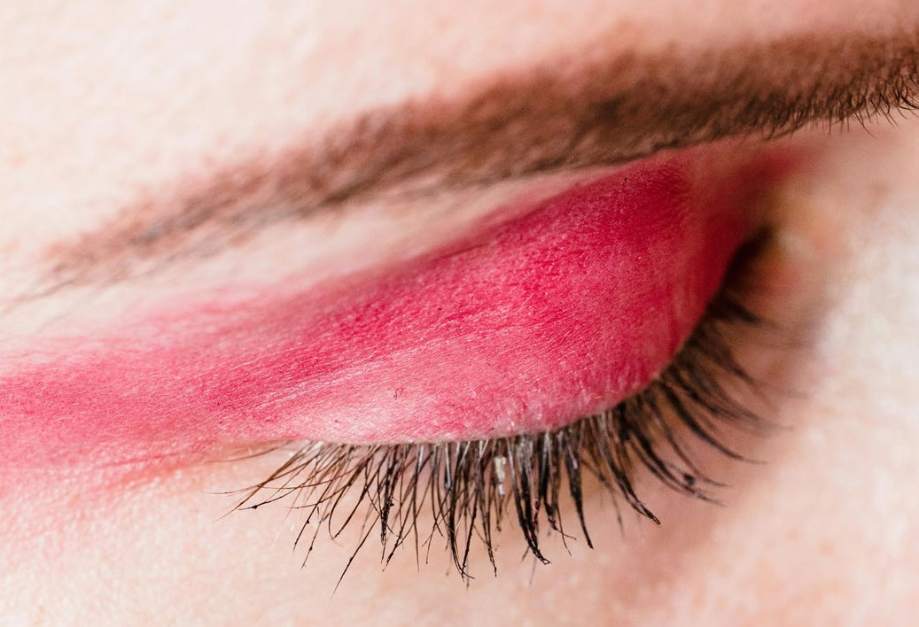

01 FROM SHOPPING TO ENTERTAINMENT

##### Brand Highlights

**Luxe Collective (UK)**

Luxe Collective (UK) is a luxury resale platform- they post educational content about fashion, with some of its videos amassing over 16m views. Recently launched on TikTok Shop, the brand hosted a limited-time live discounting event, offering 50% off bags from Louis Vuitton, Loewe and Bottega Veneta to fuel a sense of scarcity and exclusivity. They recently broke a record by being the first ever company to sell a Hermes Birkin on a TikTok Shop Livestream in the UK, demonstrating the immense potential for luxury products on TikTok Shop.

**Made By Mitchell (UK)**

In 2022, British beauty brand Made By Mitchell (UK) launched on TikTok Shop, making its products an “integral part” of the evolving beauty landscape on the platform. In late June 2024, the brand took part in TikTok Shop’s UK summer promotion, hosting a 12-hour live stream where founder Halliday sold one cosmetic product every second, generating USD 830,000 in revenue and surpassing

USD 1 million in sales within 24 hours.

Pexels

SECTION 3: #TIKTOKMADEMEBUYIT E-COMMERCE REINVENTED 12

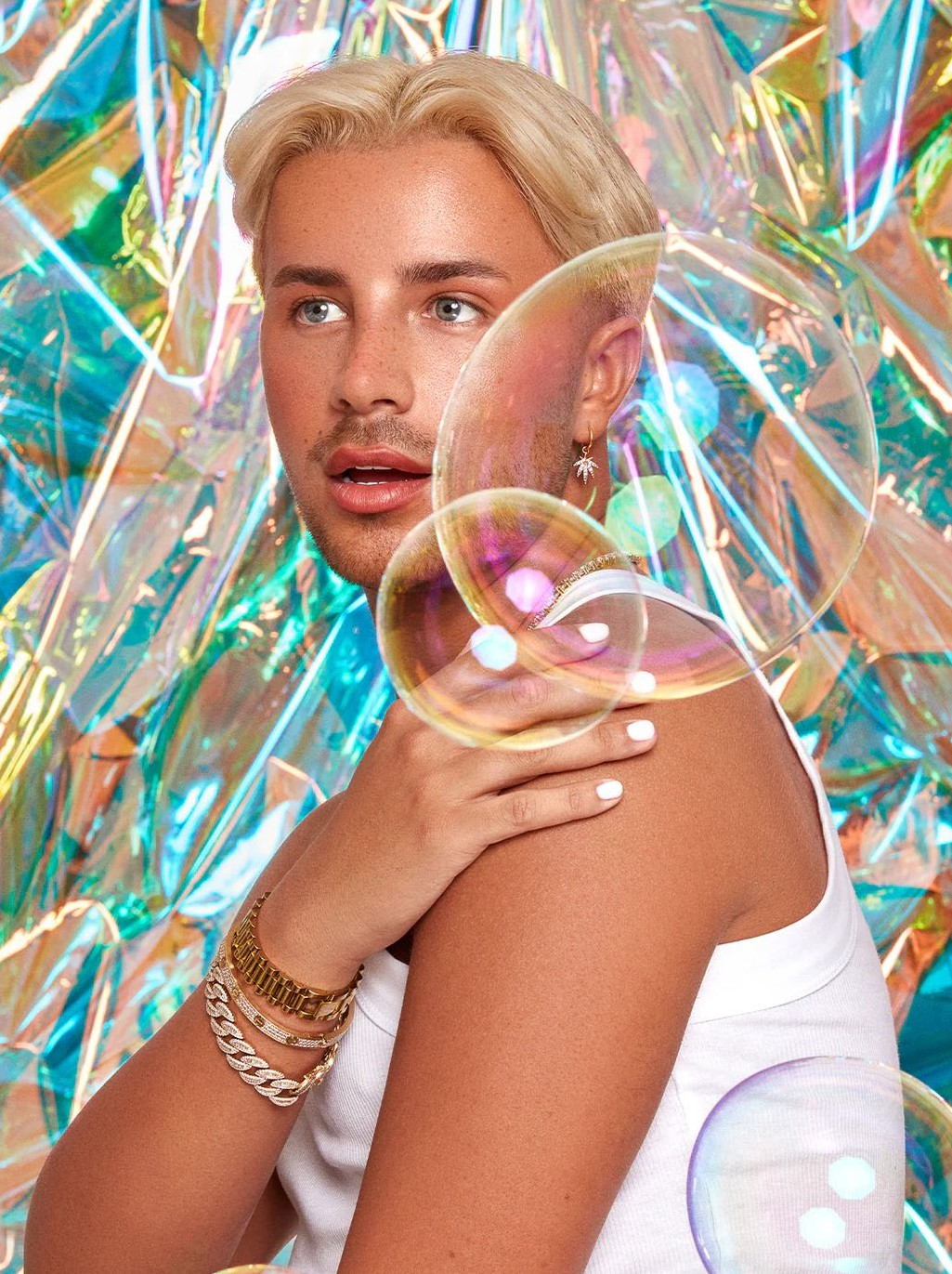

“It’s been amazing to watch Made by Mitchell grow on TikTok. We’ve been successful in tapping into broader TikTok trends, such as launching our “Barbie Bundle” to coincide with

the Barbie premiere and have made the most of TikTok Shop’s different formats, such as shoppable LIVEs and shoppable short videos, to drive sales.

Achieving $1 million in sales in 24 hours on TikTok Shop was an

incredibly proud moment. Our team put everything into making the

12-hour LIVE an exciting and enjoyable shopping experience. This milestone shows the potential TikTok LIVE shopping has to supercharge a brand.”

Mitchell Halliday, Founder, Made by Mitchell

TikTok Shop

 SECTION 3: #TIKTOKMADEMEBUYIT E-COMMERCE REINVENTED 13

##### Thoughtstarters

1. **Evolve with Soft Selling Streams**

Use livestreaming to value add to the consumer experience, going beyond hard selling tactics. Create educational stories to showcase products. Craft rich, insightful

brand stories centred on heritage and product inspiration to help shoppers uncover value.

Be active in disseminating this information to ambassadors and streamers to take control of brand narratives while building cultural capital.

1. **Livestream your creative process**

Draw in experience-hungry consumers through streaming initiatives that celebrate your creative process and that level up the entertainment value of your brand, creating

a strong narrative that keeps loyal consumers tuning in. Fashion and beauty brands should turn their creative process and brand ethos into an interactive streaming experience by inviting fans from all over the world to get a virtual front-row seat to their world. Creating

a behind-the-scenes experience not only adds entertainment value but democratises the experience, opening up new opportunities to reach and sell to consumers.

1. **Test and gather feedback**

Livestreaming can be an important method for retailers to test new products and markets, or to simply gain richer data and deeper behavioural insights into consumer preferences. Consider testing new products or initiatives on TikTok Shop. With [68%](https://www.emarketer.com/content/5-charts-showing-tiktok-shop-s-potential) of US Gen Z willing to make purchases directly from the app, brands should test and scale custom product collections as well as connect third- party e-commerce sites to their profiles.

As an example, P. Louise Cosmetics engages their consumers for feedback on their livestream, where a comment is potentially taken into account on a product brief- and this interaction feeds into product development.



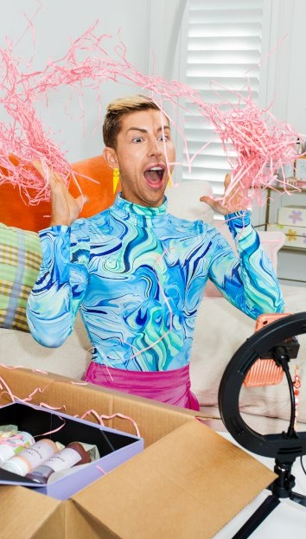

01 FROM SHOPPING TO ENTERTAINMENT

TikTok Shop

 SECTION 3: #TIKTOKMADEMEBUYIT

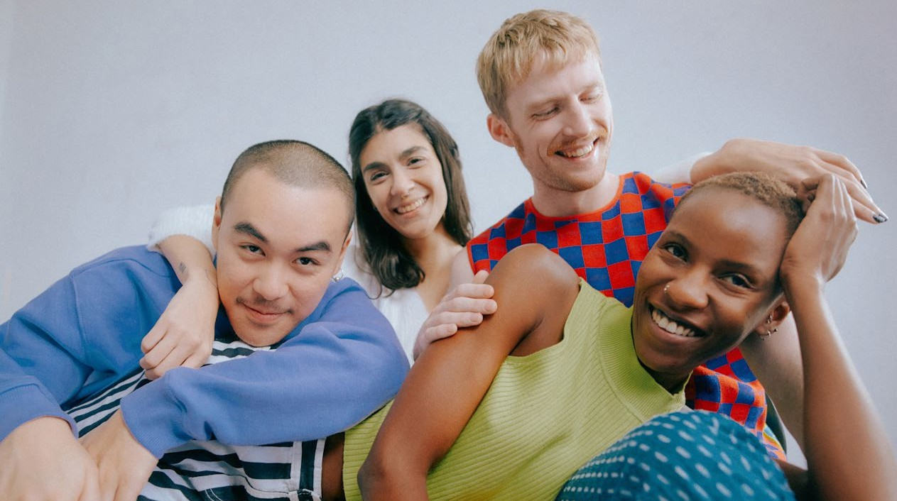

02 THE CREATOR CONNECTION

Deathtostock

E-COMMERCE REINVENTED

14

##### Authenticity at Scale

Creators are emerging as powerful cultural drivers, reflecting the values of younger, socially conscious consumers and navigating the complexities of geopolitical tensions. As the creator economy becomes increasingly democratized heading into 2027, creators will wield even greater influence, reshaping the landscape of commerce. By building immersive worlds and fostering deep connections, they not only drive their own narratives but also hold the potential to redefine the long-term success of the brands they collaborate with, drawing in loyal shoppers along the way.

**This shift from brand-led marketing to creator- driven influence mirrors a larger desire for social connection.** Consumers today prioritize authenticity, relatability, and trust—qualities creators excel at through personal storytelling and

direct engagement with their audiences. As a result, creator-led communications resonate deeply, offering both consumers and brands the sense of community they crave.

Brands partnering with creators benefit from this authentic dialogue, gaining access to new

audiences and driving 2.4 times higher engagement rates on creator-led ads compared to traditional content. By leaning into this dynamic, businesses can strengthen credibility, boost conversions, and cultivate communities that foster long-term loyalty.

$500bn

Goldman Sachs estimates the creator economy could be a

[$500bn](https://www.goldmansachs.com/insights/articles/the-creator-economy-could-approach-half-a-trillion-dollars-by-2027) industry by 2027.

Goldman Sachs, 2023

Gen Z consumers are

## x

3.5

more likely to say social media creators – not brands – are responsible for trends, so brands should lean into the creator economy to drive conversion.



[Vogue Business, 2023](https://www.voguebusiness.com/technology/can-fashion-week-help-the-industry-crack-social-commerce)

 SECTION 3: #TIKTOKMADEMEBUYIT E-COMMERCE REINVENTED 15

On TikTok Shop, creators have become the heart of the platform, building loyal communities that trust their recommendations and view them as relatable, authentic figures. Engaging creators on TikTok Shop enables brands to tap into this trust and authenticity, allowing products to be promoted in an fluid, genuine manner that connects with TikTok’s many subcultural communities.

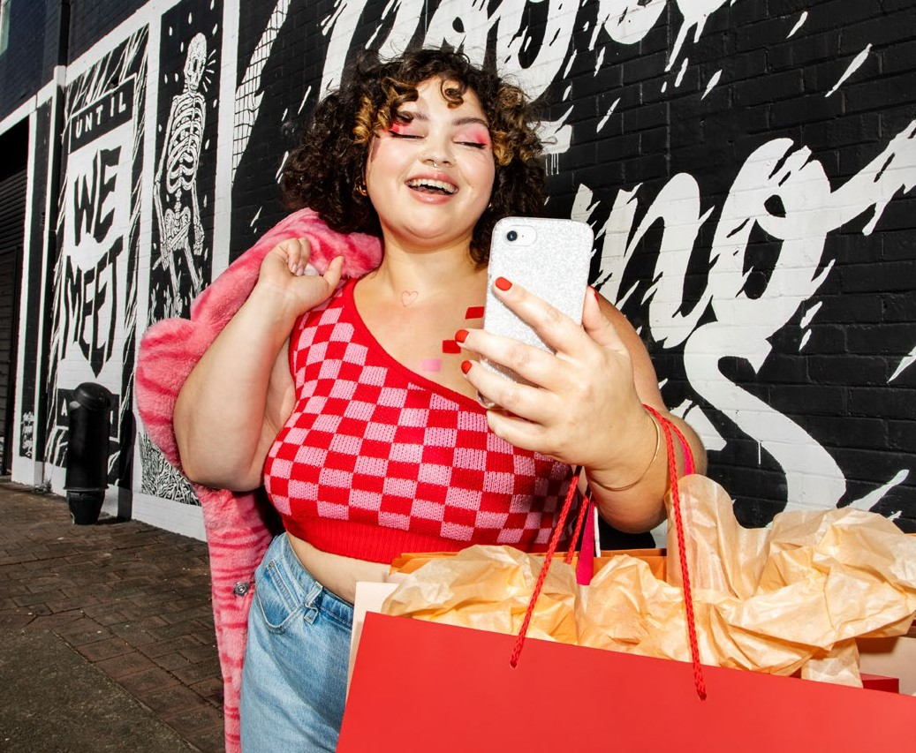

AUTHENTICITY AT SCALE

02 THE CREATOR CONNECTION

Collaborating with creators on TikTok Shop allows brands to reach a wider audience through authentic, relatable content. But beyond this, it also drives full funnel success. By leveraging Shoppable Videos and LIVEs created by TikTok Shop’s community of over 100,000 creators, brands can drive traffic to their store without the need to produce content independently. This model operates on a commission basis, where brands only pay when a creator’s content generates sales, providing valuable reach, awareness, and promotional content. Through the Affiliate Center in TikTok Shop’s Seller Center, businesses can easily discover and connect with creators, adding fresh voices to their promotional efforts and maximizing engagement.

TikTok Shop

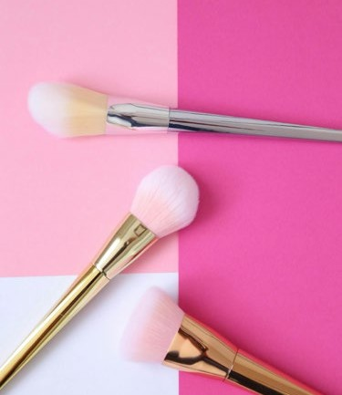

Pexels

Three years ago, influencer marketing was on the periphery.

Now, creators are not just creating the

content, they’re helping shape the strategy.

Scott Guthrie, Influencer Marketing Trade Body, [2024](https://influencermarketinghub.com/tiktok-marketing-report/)

Ad spending on influencer marketing in the UK is expected to reach

## bn

£1.3

(US$1.63bn) in 2029.

Statista, [2024](https://www.statista.com/forecasts/1445521/influencer-advertising-spending-uk)

 SECTION 3: #TIKTOKMADEMEBUYIT E-COMMERCE REINVENTED 16

02 THE CREATOR CONNECTION

##### Brand Highlights

**ASOS (UK)**

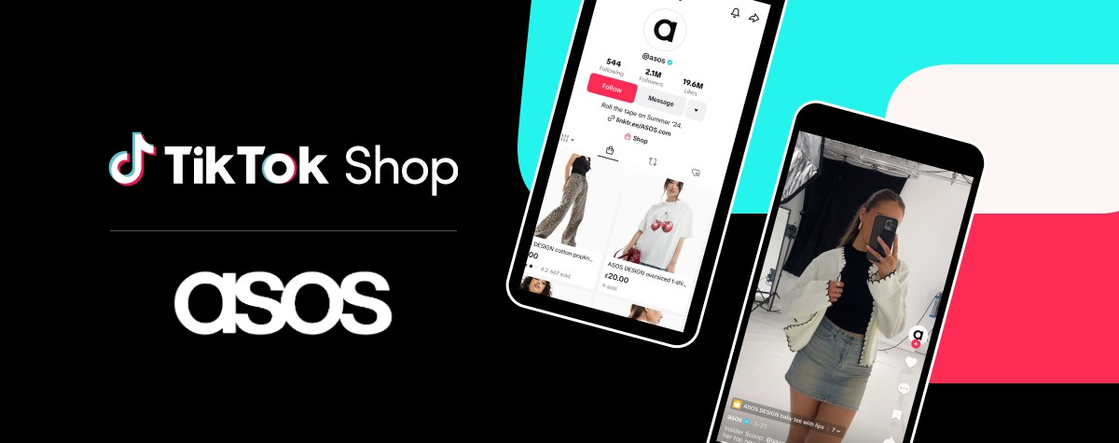

ASOS (UK) tapped into TikTok Shop to broaden its customer base, partnering with 30 ASOS Creators and 30 TikTok Creators in its initial rollout. Collaborating closely with TikTok Shop’s enablement team, the brand provided creators with in-depth training on platform tools, content optimization, and strategic product promotion to maximize engagement.

This creator-first approach delivered impressive results: 57% of customers acquired were new to ASOS, with 45% aged 18-24. By equipping creators with the skills to succeed, ASOS seamlessly connected with TikTok’s vibrant community, boosting brand visibility and driving significant sales growth.

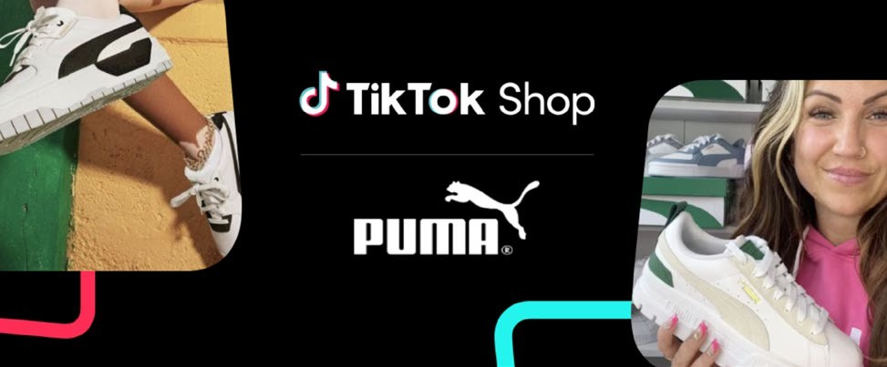**PUMA**

PUMA participated in TikTok Shop’s one-week April Deals campaign with the goal of boosting sales and increasing brand awareness. By tapping into the #FashionTok community and fully leveraging the features and capabilities of TikTok Shop, PUMA aimed to connect with a broader audience, engage potential customers, and drive significant

sales growth during the campaign period. They collaborated with TikTok creator @dawnlovex- this affiliate partnership played a pivotal role in the campaign, as Dawn went LIVE five times to engage directly with

her TikTok community. She showcased the ‘Mayze’ shoes in real-time, provided detailed product insights, Q&As and creating FOMO around the limited-time offer. Dawn also produced a series of Short Videos before and after her LIVEs to build anticipation in the lead up to the events and maintain engagement afterward. By integrating these Short Videos with her LIVEs, she was able to reach a wider audience, create continuous buzz, and drive sustained interest in PUMA’s ‘Mayze’ shoe.

 SECTION 3: #TIKTOKMADEMEBUYIT E-COMMERCE REINVENTED 17



“Matchmaking Creators and brands at scale is one of the biggest levers of success. I think brands need to be experimental with the channel right from the start. We discuss with PUMA

every week together, and they change as we go. For example, we changed from an official selective plan to an open plan. This was a big lever, as Creators then reach out to brands, and the performance picked up massively. ”

Gustavo Mondo,

Head of Fashion Account Management, TikTok Shop UK

With reference to how PUMA strategically leveraged the platform’s unique features to create immersive shopping experiences

Unsplash

 SECTION 3: #TIKTOKMADEMEBUYIT E-COMMERCE REINVENTED 18



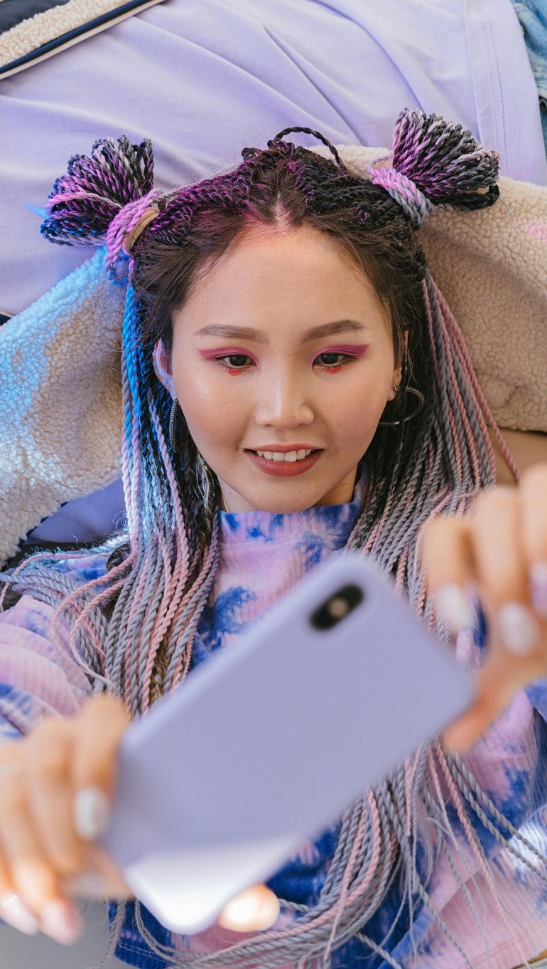

02 THE CREATOR CONNECTION

##### Thoughtstarters

1. **Find the right match**

When evaluating creators, consider business metrics like category, audience, and past sales performance—readily available through TikTok Shop’s Affiliate Center—alongside their cultural fit and communication style.

Focus on influencers who genuinely align with your brand’s ethos and resonate with your audience. To ensure a successful partnership, thoroughly assess their core messaging, principles, and overall alignment before committing.

1. **Invest in the partnership**

Co-create with creators and their communities to develop content that resonates deeply. Go beyond one-off sponsorships - drive lasting engagement with their followers by launching episodic series and immersive digital experiences.

In an era where entertainment defines success, co-creating informative, educational, and engaging content with consumers’ favorite online personalities will capture today’s fleeting attention.

1. **Focus on consistency and experimentation**

Consistency is key to building momentum and connecting with the right audience. Prioritize ongoing partnerships to keep your products in the spotlight.

In addition to that, start experimenting early, exploring new formats, creators, and strategies. Refine your approach based on what works, and stay agile—pivoting quickly to maximize impact and drive results.

Pexels

 SECTION 3: #TIKTOKMADEMEBUYIT

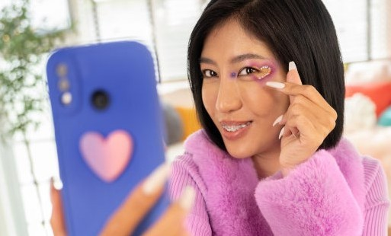

03 JUMPING ON THE TREND CYCLE

E-COMMERCE REINVENTED

19

TikTok Shop

##### The speed of culture

In the past, fashion trends trickled down from the elite to the masses, with centralized media channels in the 1960s acting as the primary driver of style. Fast-forward to today, and social media has upended this system, eliminating gatekeepers and fostering

peer-to-peer influence that drives trends at lightning speed. **Platforms like TikTok have fundamentally reshaped the trend cycle, accelerating adoption, redefining personal style, and fueling sales—all while**

**satisfying a deep social need for connection and belonging.**

TikTok thrives as a trend incubator, with new aesthetics emerging almost daily. From Y2K styles to niche movements like #Regencycore, the platform’s ability to amplify hyper-specific trends reflects the rise of communities built around shared identities. This inherently social dynamic fosters a sense of belonging as users participate in and contribute to the trends that define their cultural moment.

For brands, TikTok is a vital pulse-check on cultural shifts, offering real-time insights into what resonates. With trends gaining

momentum in hours rather than weeks, agility and relevance are no longer optional—they’re essential for staying ahead in a constantly evolving trend landscape.

88%

of Gen Z visit social and entertainment platforms after making a purchase with a retailer or brand (e.g. to share experience or leave review, watch how-to videos, contact brand).

Retail Economics, [2024](https://www.retaileconomics.co.uk/retail-insights/thought-leadership-reports/the-power-of-social-commerce-building-brands-in-the-tiktok-era)

UK beauty consumers tend to spend

more on cosmetics via TikTok Shop than the average online cosmetics buyer has done over the last 12 months.

£33

Nielsen IQ, [2024](https://www.cosmeticsdesign-europe.com/Article/2024/06/18/Selling-cosmetics-on-TikTok-Shop-4-expert-tips-for-success/)

 SECTION 3: #TIKTOKMADEMEBUYIT E-COMMERCE REINVENTED 20

THE SPEED OF CULTURE

03 JUMPING ON THE TREND CYCLE

TikTok Shop is the UK’s ultimate trend-to-cart powerhouse, turning viral moments into instant sales. When users spot a must-have item in a trending video or challenge, they can snag it right then and there—no detours, no fuss. It’s all about riding the hashtag wave and turning TikTok buzz into buy-now action.

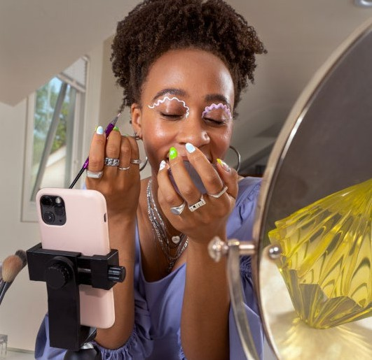

TikTok Shop

The platform’s live shopping feature drives up the engagement, letting brands host real-time product showcases tied to seasonal trends or cultural moments. Think live demos during a viral challenge or exclusive drops synced with trending hashtags—perfect for driving sales and keeping audiences hooked.

TikTok Shop doesn’t just amplify your online presence—it plugs brands straight into the cultural zeitgeist. By leveraging viral videos, trending sounds, and UGC gold, it’s a one-stop shop for boosting visibility, blending seamlessly into the TikTokverse, and building a strong digital identity.

More than a third of TikTok users buy something they see from the platform, and 37% immediately purchase something after discovering it on the app.

37%

ROOT, [2024](https://rootdigital.co.uk/blog/tiktok-shop-statistics/)

“It is essential to stay agile, adapt quickly to trends, and create content that is relatable and engaging for the audience.”

LOAD Creatives, 360° Creative Marketing Agency based in Denmark, for Vocast, [2024](https://vocast.com/craking-tiktoks-trend-code-how-brands-can-flourish-on-tiktok)

 SECTION 3: #TIKTOKMADEMEBUYIT E-COMMERCE REINVENTED 21



##### Brand Highlights

03 JUMPING ON THE TREND CYCLE

**Trigwell Cosmetics (UK)**

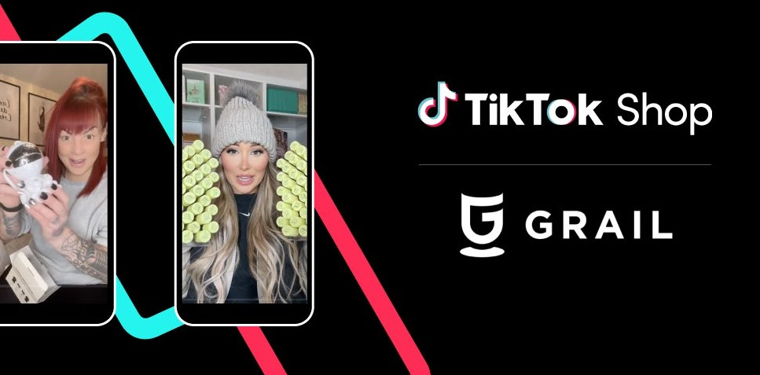

Trigwell Cosmetics (UK), launched in 2020 by founder Zoe Trigwell, adopted a TikTok-first approach to elevate brand awareness and drive revenue. Now known for their TikTok-viral Velvet Powder Puff, the brand tapped into trending sounds, such as ASMR and voiceovers, while producing product-focused content. By using native Shoppable Videos, LIVES, and spark ads, they showcased their Limited Edition Powder Puff Bundle in engaging, sales-driven formats, effectively boosting TikTok Shop sales.

Their TikTok-first strategy extended beyond their core beauty audience, utilizing interest-based targeting to attract new customers and highlight the platform’s diverse user base. By blending trending audio formats with product-heavy storytelling, Trigwell Cosmetics successfully turned viral moments into sales, reinforcing TikTok as a key channel for brand growth.

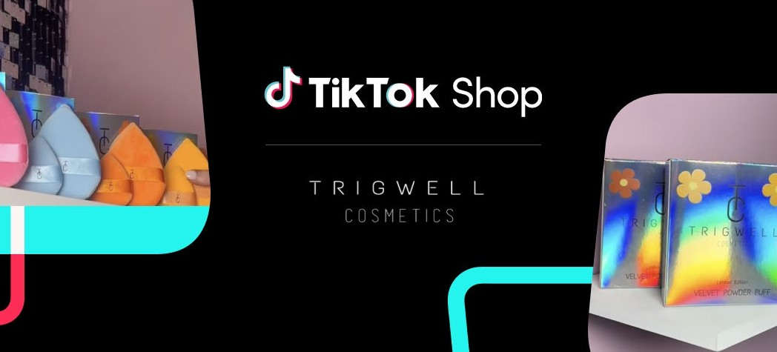

**Grail (UK)**

Grail (UK), our local Creator Agency Partner (CAP), achieved a record- breaking $2M in sales in November 2023, with a standout performance during the Black Friday period. Their success stemmed from the strategic focus: in addition to partnering with the right creators and leveraging short video content, Grail was on top of emerging trends.

Grail’s ability to adapt quickly to unpredictable viral moments was a key driver of their results. Viral products, often influenced by

trending content or last-minute brand promotions, present significant opportunities for growth. By closely monitoring campaign performance and acting on real-time insights from their CAP POC, Grail swiftly created additional content and optimized their focus on high-potential products, merchants, and promotions. This agile approach maximized GMV and capitalized on every opportunity throughout the campaign.

 SECTION 3: #TIKTOKMADEMEBUYIT E-COMMERCE REINVENTED 22

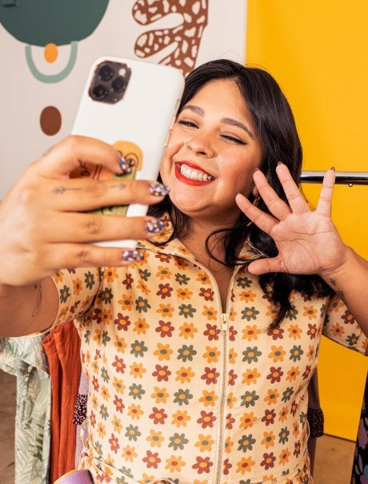

“TikTok is an exciting platform - for consumers as well as brands. The constant stream of new content and inspiration grant exposure to small and emerging brands as well as household names. This leveled playing field gives a real chance to challenger brands and disruptors in the beauty and personal care space, meaning there are always new beauty brands to discover”

Claire Marty, Global VP of Beauty at Nielsen IQ, [2024](https://www.cosmeticsdesign-europe.com/Article/2024/06/18/Selling-cosmetics-on-TikTok-Shop-4-expert-tips-for-success/)

TikTok Shop

 SECTION 3: #TIKTOKMADEMEBUYIT E-COMMERCE REINVENTED 23

##### Thoughtstarters

1. **TikTok as social listening**

TikTok can offer real-time insights into top trends, and brands can obtain social insight by searching hashtags and reading comments.

The platform has evolved to become a culture hub where a myriad of trends emerge daily. It provides brands with real-time intelligence into emerging interests and consumer sentiment.

1. **Make trends tangible**

Brands can tap into current trends and make those come to life by curating their TikTok Shop shelves around those rising cultural movements.

Having a section of your shop include TikTok viral products can attract the extremely online consumer and entice new purchases via the hashtag #TikTokMadeMeBuyIt. Brands can rely on TikTok Shop’s Product Opportunities feature, that provides insights into trending products that shoppers are searching for

and purchasing, enabling sellers to align their offerings with current market demand.

1. **Have fun with your audience**

[As 91% of people prefer brands to be funny](https://www.prnewswire.com/news-releases/global-report-45-of-people-have-not-felt-true-happiness-for-more-than-two-years-301568258.html)  [and 72% would choose a brand that uses](https://www.prnewswire.com/news-releases/global-report-45-of-people-have-not-felt-true-happiness-for-more-than-two-years-301568258.html)  [humor over the competition](https://www.prnewswire.com/news-releases/global-report-45-of-people-have-not-felt-true-happiness-for-more-than-two-years-301568258.html), brands have an opportunity to use TikTok Shop as a canvas to express their unique identity.

By embracing a playful and engaging tone, brands can move beyond traditional

boundaries to nurture personal affinity. TikTok Shop encourages experimentation, offering

a space to innovate, captivate, and build meaningful relationships with consumers in an interactive and culturally relevant environment.



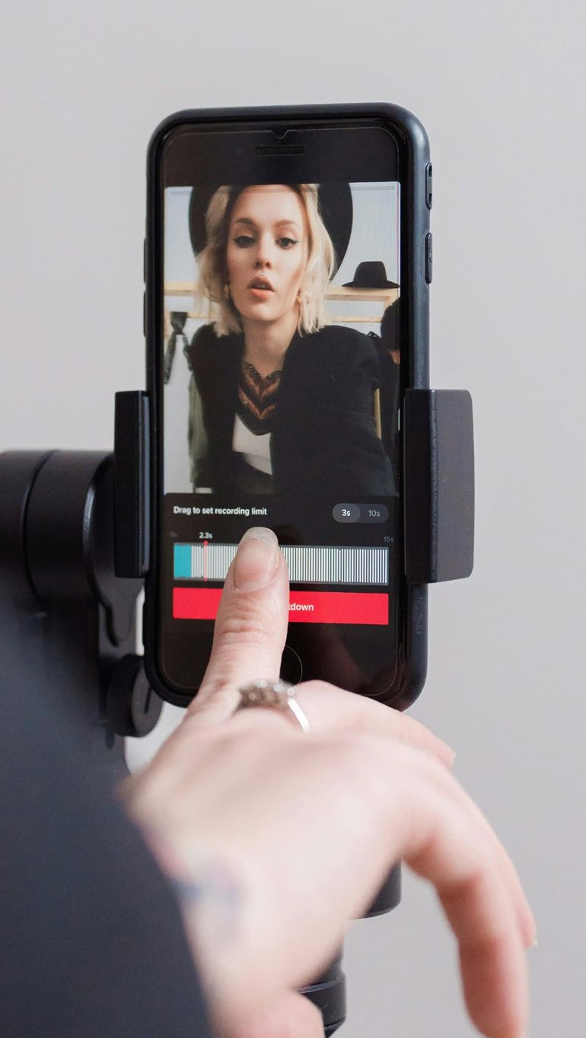

03 JUMPING ON THE TREND CYCLE

Pexels

 SECTION 4: DO IT FOR THE TREND E-COMMERCE REINVENTED 24

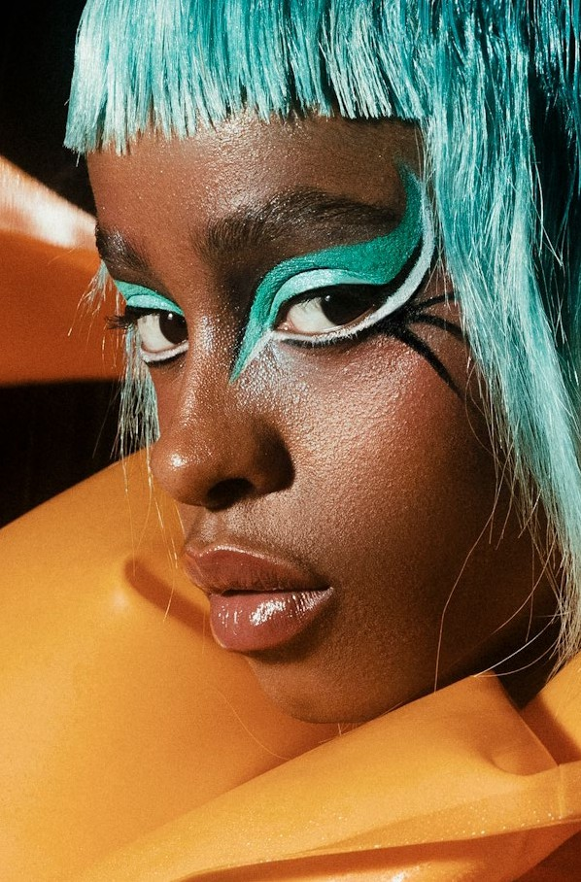

# Do It For The Trend

#### Trends and Opportunities for 2025



Deathtostock

 SECTION 4: DO IT FOR THE TREND E-COMMERCE REINVENTED 25

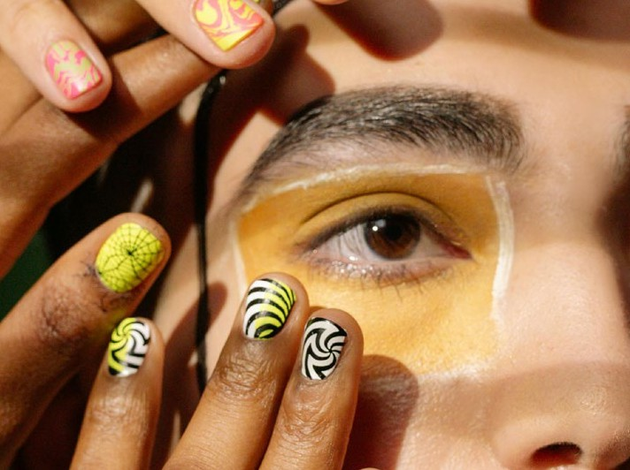

#### Trends and Opportunities

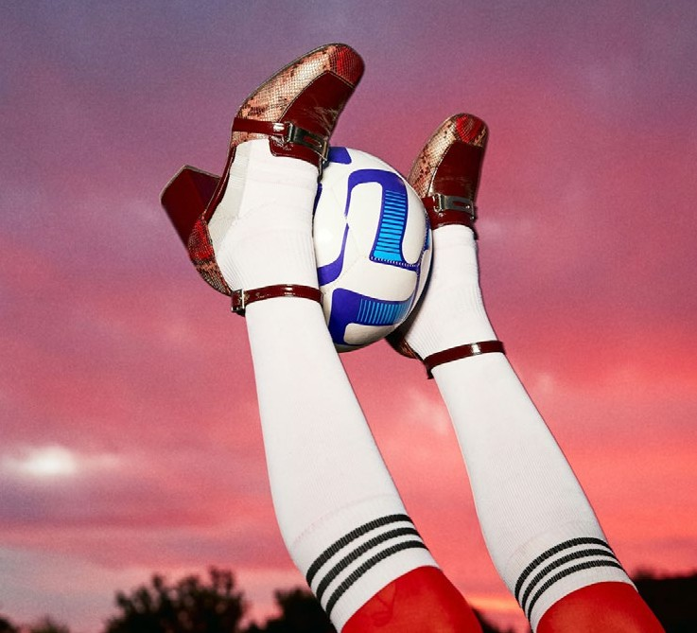

Deathtostock

02

Pexels



01



Deathtostock

03

###### 01 Perspectives on Perfection 02 The Rise of Sports Fandoms 03 Nuanced Glimmers

 SECTION 4: DO IT FOR THE TREND E-COMMERCE REINVENTED 26

#### Perspectives On Perfection

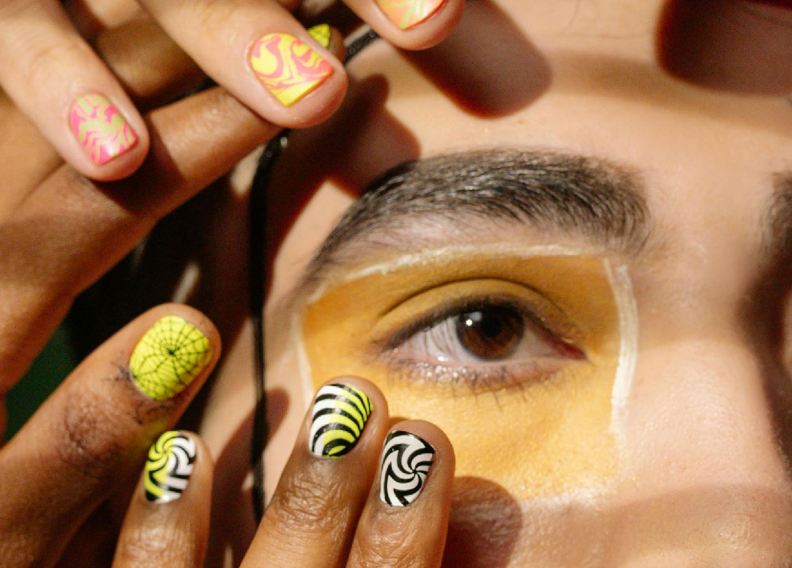

Pexels

###### Gen Z is seeking new ways to redefine and navigate perfection and wellness culture. For brands, it’s time to broaden perspectives on perfection to embrace new aesthetics, encourage different routines, and offer broader definitions on what it means to be ‘well’ and beautiful.

 SECTION 4: DO IT FOR THE TREND E-COMMERCE REINVENTED 27



Unsplash

##### What is the context?

TREND 01 PERSPECTIVES ON PERFECTION

Young consumers are expanding their perspectives on beauty and fashion, embracing diverse forms of self-expression, inclusive body standards, and aesthetics that encourage greater authenticity from brands and marketers. They are fostering a new culture and communities that celebrate individuality and playfully redefines and explores more fluid notions of traditional beauty and fashion norms.

Rather than turning away from makeup or skincare, they are embracing it by exploring products, trends, and aesthetics in innovative ways that support a broader beauty notion.

As chrono-normativity evolves, Gen Z will also look to brands that support their unique journeys, whether through lifestyles that don’t follow traditional timelines or unconventional approaches to adulthood.

Products and marketing that adapt to this broader notion of what’s beautiful,

nurture a sense of belonging and encourage people to connect through shared values are well-positioned to resonate with this generation’s values.

[40%](https://adage.com/article/opinion/why-gen-z-wants-be-brand-co-creators/2435896) of global consumers are GenZ, with a spending power of [$7tn](https://adage.com/article/opinion/why-gen-z-wants-be-brand-co-creators/2435896). As the largest and most diverse generation, their advocacy for people and the planet is redefining beauty culture, focusing on individualised skin and hair health diversity, identity exploration through cosmetics and fragrance, and anti oppressive wellness practices.

“The body positivity movement has led to more inclusivity in the realm of what is considered beautiful.”



Dr Jaishree Sharad, Celebrity Dermatologist, [2024](https://www.theestablished.com/self/beauty/why-is-gen-z-oscillating-between-unapologetic-body-acceptance-and-unrealistic-beauty-standards)

 SECTION 4: DO IT FOR THE TREND E-COMMERCE REINVENTED 28

TREND 01 PERSPECTIVES ON PERFECTION

##### How is the trend expressed?

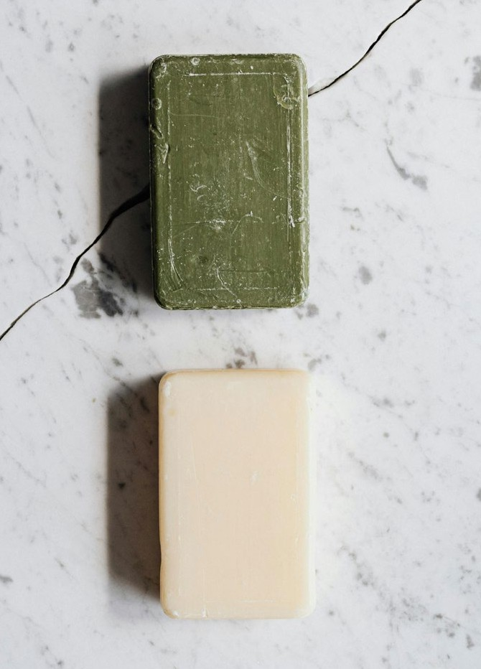

Pexels

**Brand spotlight: DCYPHER Cosmetics**

While many beauty brands are still struggling to offer shades for all skin tones, DCYPHER

Cosmetics (UK) is paving the way for new colour innovation using a combination of colour science and AI that generates a wider variety of shades.

**/ Unconventional Beauty**

Consumers are progressively creative with redefining standards of beauty, embracing unconventional aesthetics that defy traditional norms. This will be increasingly reflected across both beauty and fashion, where a playful embrace of styles “break the rules.” The

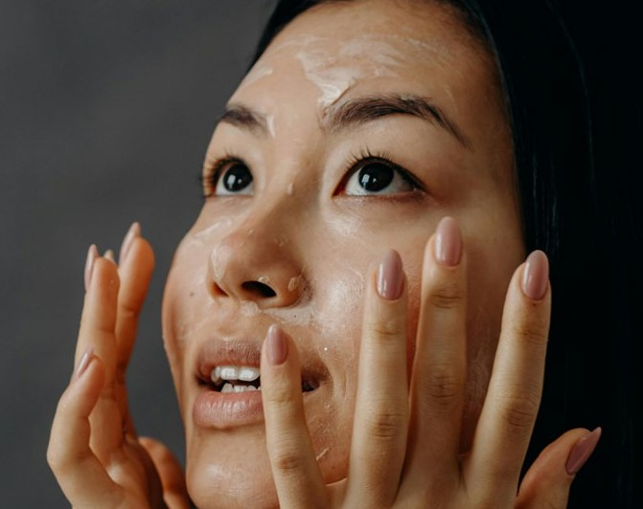

Pexels

“Pre-Shower Makeup” trend on TikTok shows creators applying bold, experimental makeup looks they’d never wear in public. Similarly

in fashion, people are experimenting with outrageous or layered looks simply for the joy of trying something different.

**/ Fluid Self-Expression**

In a digital landscape where beauty trends shift with every swipe, rising beauty subcultures

**Brand spotlight: Too Faced**

Too Faced (UK) Designed a Hangover 3-in-1 set with today’s fast-paced, nocturnal driven lifestyle in mind, making it perfect for those who need

a beauty routine that fits into busy schedules. Whether it’s after a late night out or a long day of work, the Hangover set helps users look

revitalized and refreshed effortlessly, reflecting the growing demand for beauty products that support modern lifestyles.

are empowering Gen Z to experiment with diverse looks and identities. Temporary beauty formats will appeal with the rise of polymorphic beauty—encouraging endless mix-and-match possibilities. With transformation and self- expression at its core, this trend enables beauty enthusiasts to adapt their appearance daily, reflecting their mood and individuality.

 SECTION 4: DO IT FOR THE TREND E-COMMERCE REINVENTED 29

TREND 01 PERSPECTIVES ON PERFECTION

**/ Evolving Masculinity**

**Brand spotlight: STARFACE**

STARFACE is a acne patch that aims to turn “breakouts into moments of self-expression and fun with dermatologist-approved essentials that care for skin with kindness”

By 2026, the male grooming market will embrace a more inclusive and progressive approach, breaking away from traditional gender narratives to meet the evolving needs of men’s grooming and beauty. Driven by Gen Z’s influence, toxic masculinity and hyper- masculine rhetoric are giving way to more enlightened perspectives that prioritize self- care, a shift accelerated by the pandemic.

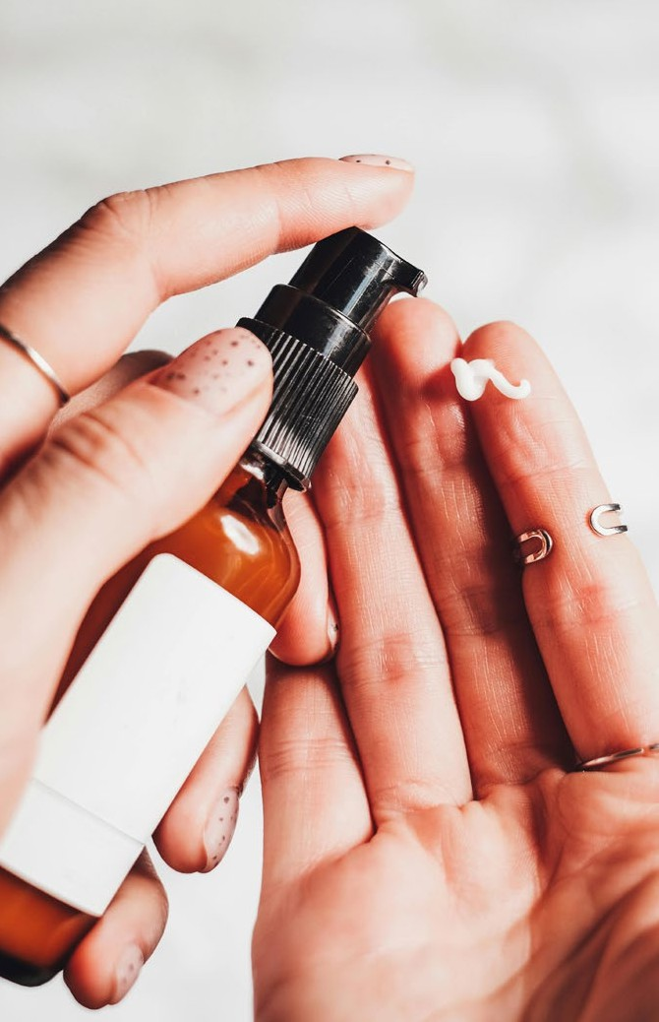

Pexels

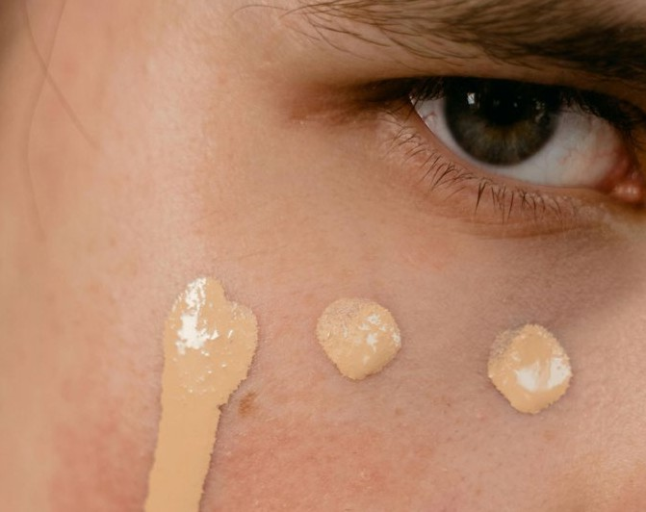

Pexels

This evolution has also dismantled rigid gender boundaries, enabling men to explore creative self-expression and redefine masculinity in ways that feel authentic and diverse.

**/ Guilt-Free Simplicity**

Consumers facing high levels of burnout will view laziness and simplicity as pleasurable therapeutic practices. Practices such as

**Brand spotlight: Michaela Stark**

UK designer Michaela Stark debuted her first line of lingerie along with a performance art piece, both designed to emphasise body parts women are usually told to hide

bed-rotting will be upgraded through beauty products that aid relaxation or promote doing ‘nothing’. Products that do more with minimal effort will be critical, such as beauty products that can be worn while the user is sleeping.

 SECTION 4: DO IT FOR THE TREND E-COMMERCE REINVENTED 30

TREND 01 PERSPECTIVES ON PERFECTION

##### How can TikTok Shop turn Trend into Action?

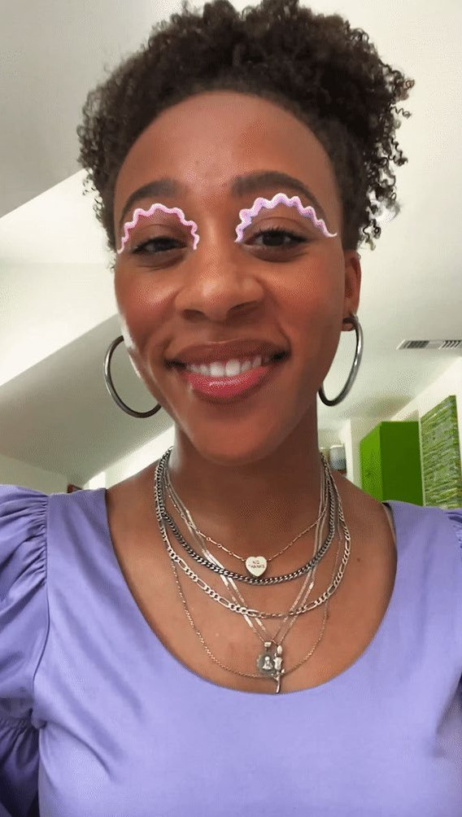

TikTok Shop

As Gen Z embraces broadened definitions of beauty and alternate expressions, TikTok Shop presents brands with an extraordinary opportunity to connect authentically with this forward-thinking audience. Brands can get creative with the platform’s tools to offer products that celebrate individuality and self-expression.

**Case Study: Glow For It**

[Glow For It](https://www.tiktok.com/%40glowforitshop?lang=en), founded in 2020 during lockdown with a simple yet powerful vision, has grown into a multi-award- winning beauty brand known for its innovative, solution-driven products that enhance natural beauty.

To elevate brand awareness and attract new customers, the company strategically engaged over 200 handpicked creators through TikTok Shop’s Affiliate Program.

Glow For It initiated a targeted sampling and content creation campaign, which enabled the brand to authentically showcase its products within diverse, relatable contexts, effectively reaching a broader audience.

The impressive results came fast: the brand saw a 73.43% boost in revenue, with $68K coming directly from Creators within one month - a 160% increase in affiliate sales that reflects the benefits of strategic creator partnerships.

They can, for example, leverage TikTok Shop’s suite of tools designed to harness the power of creator collaborations, inviting a diverse group to reveal the real, creative, and unique sides

of beauty and style. Partnering with creators who embody the “alternative beauty” ethos will enable brands to reach Gen Z consumers through trusted voices who resonate deeply with this trend.

Through TikTok Shop’s discovery on the “For You” page, brands embracing this new aesthetics can appear before consumers

ready to broaden their definitions of beauty, encouraging shared experiences and building collective trust while inspiring purchases that feel personal and meaningful.

 SECTION 4: DO IT FOR THE TREND E-COMMERCE REINVENTED 31

##### Brand Takeaways

1. **Represent Broadened Perspectives**

Rather than promoting traditional ideals of perfection, explore how your brand can engage consumers inclusively, encouraging them to express themselves, support one another, and uplift their community. Create a space where everyone feels welcome, served and seen.

For example, TikTok Shop’s shoppable video format offers a chance to highlight self-care with a fresh, inclusive approach. By featuring products that celebrate individuality and self-expression, brands can align with the authentic, fluid values that resonate with younger audiences today.

1. **Encourage Creative Expression**

Stimulate your followers to revel in creativity and messy play, such as the trend of

“anti-perfectionist make-up” - expressive, spontaneous and open to all.

Labelled ‘girl gaze make-up’ by Rachel Strugatz in the New York Times, this post pandemic movement was fuelled by HBO’s Euphoria

and MUA Donni Davy’s ‘make-up freestyling’, appealing to consumers who previously felt they lacked skills or creativity. For example, P.Louise invites followers to break the rules using their coloured bases, perfect for bold, exuberant make-up looks.

Partnering with influencers who embody creative freedom through beauty and fashion can speak to a brand’s authenticity and connect with even more consumers.



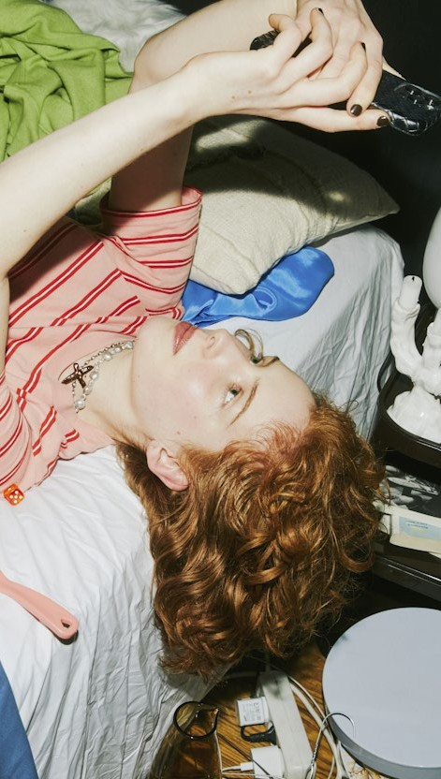

TREND 01 PERSPECTIVES ON PERFECTION

Deathtostock

 SECTION 4: DO IT FOR THE TREND E-COMMERCE REINVENTED 32



#### The Rise of Sports Fandoms

Deathtostock

###### As sports sponsorships and viewership grows, brands must reconsider their strategies to capture new sports fandoms online and offline.

 SECTION 4: DO IT FOR THE TREND E-COMMERCE REINVENTED 33



##### What is the context?



TREND 02 THE RISE OF SPORTS FANDOMS

Growing interest in sport represents a golden opportunity for brands to reach new, more diverse demographics. Viewership is at an

all-time high: [four billion](https://sportytell.com/sports/most-popular-sports-world/) global fans watched football and one billion people watched tennis in 2023. Where and how people are watching is also changing - increasingly centered on individual athletes rather than teams, favoring highlight clips and social media interactions with star athletes over traditional viewing.

Gen Z fans are redefining engagement, and this shift is driving sports franchises to innovate, forging new partnerships and adopting fresh content formats to connect with this digitally native audience.

TikTok is one if the platforms that young sports fans are going to for news and updates. The app’s sports hub features a range of content, from extreme sports to football highlights and UFC games, and in August

it partnered with FIFA to feature the 2023 Women’s World Cup, in addition to TikTok’s own dedicated hub with content from official broadcasters, national teams, behind-the- scenes and live pre-match content.

**Fashion x Sports**

The intersection of fashion and sports resonates with Gen Z. Princess Anne’s practical and sporty attire during the 2024 Paris Olympic Games, [including her Adidas](https://www.thetimes.com/life-style/fashion/article/princess-anne-sunglasses-fashion-ds0cchpb7?utm_source=chatgpt.com&region=global)  [accessories](https://www.thetimes.com/life-style/fashion/article/princess-anne-sunglasses-fashion-ds0cchpb7?utm_source=chatgpt.com&region=global), became a viral sensation among Gen Z, highlighting the influence of sports fashion on this demographic.

%

77

of global sports fans are interested

in fashion and merchandise that reflects their support for favourite teams and players.

GWI, [2024](https://gwihelpcenter.zendesk.com/hc/en-us/articles/7457186426908-Sports-Insights-from-GWI-Zeitgeist-November-2024)

%

of Millennial and 60% of Gen Z women in Europe consider themselves avid sports fans. Nearly one third of them watch sports- related video content, proving a growing appetite for the genre.

69

Ypulse, [2023](https://www.ypulse.com/article/2023/07/27/we-womens-sports-is-booming-among-young-females-in-europe-right-now/)

Unsplash

 SECTION 4: DO IT FOR THE TREND E-COMMERCE REINVENTED 34

TREND 02 THE RISE OF SPORTS FANDOMS

##### How is the trend expressed?

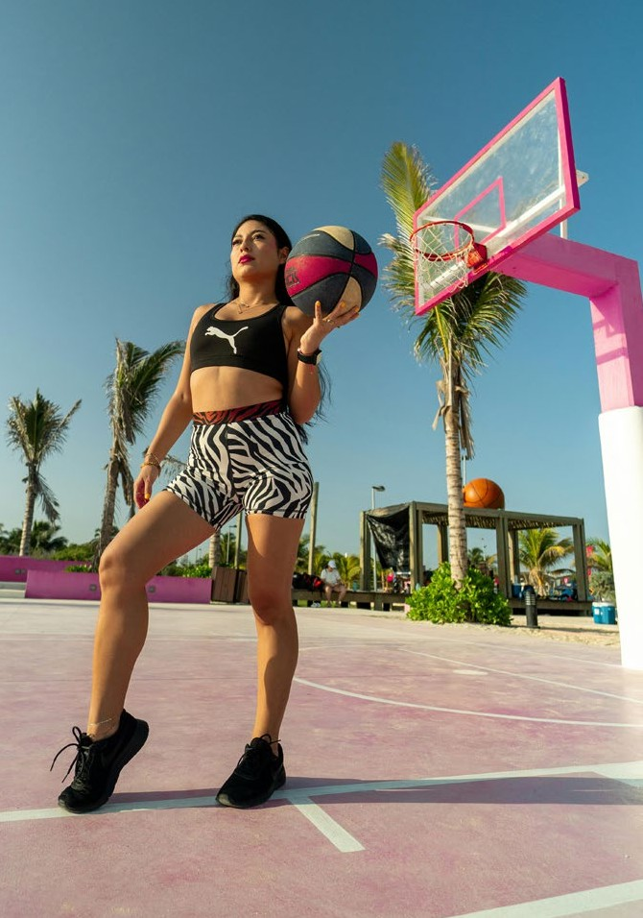

Pexels

**/ Rise of Female Fandoms**

Women account for [40%](https://tuckercenter.umn.edu/tuckercenter/projects/mediacoverage.html#%3A~%3Atext%3DForty%20percent%20of%20all%20sports%2Cportrayed%20in%20sexually%20provocative%20poses) of sports professionals globally but only receive 4% of sports media coverage. Three in five sports fans in the



UK would like to see more brands engage in women’s sports sponsorship, and [16%](https://www.womenssporttrust.com/womens-sport-trust-produces-comprehensive-industry-report-into-the-positive-impact-of-womens-sport-sponsorship-on-brands/) are willing to buy from a brand that sponsors women’s sports. In the next decade, women’s sports

is estimated to become a $200bn industry worldwide. Women sports fans are flocking to TikTok, where they share game recaps or show support for their favourite athletes via hashtags such as #WomensTennis and #FootballWomen (27.9m views and 205.9m views respectively).

**/ Niche cultural capital hype**

Merchandise acts as a symbol of belonging and a tool to demonstrate loyalty to a brand or club. IYKYK merchandise (Gen Z slang for ‘if you know you know’) can also generate hype among consumers. Brands that collaborate with popular or local sports teams to launch

merchandise that resonates with superfans will see success.

**Brand spotlight: TeamGB**

TeamGB brought the fans many highlights from the Paris Olympics on TikTok, while allowing them to buy official merch through TikTok Shop

Pexels

**Brand spotlight: Gymshark**

Gymshark: billboard was unveiled in August by the British fitness apparel brand, which enlisted American Muslim fitness creator Leana Deeb. The campaign aimed to empower women to embrace their individuality





 SECTION 4: DO IT FOR THE TREND E-COMMERCE REINVENTED 35

TREND 02 THE RISE OF SPORTS FANDOMS

**/ Athletic beauty empowering inclusivity**

**Brand spotlight: Charlotte Tilbury**

Charlotte Tilbury became the first beauty brand to partner with the F1 Academy. The initiative aims to nurture and prepare female drivers for advancement to higher tiers of racing. Women now make up 40% of F1’s fan base, and the 2022 season achieved a total viewership exceeding 1.5bn

Exposure to sports - and solutions for athletes - are making narratives previously

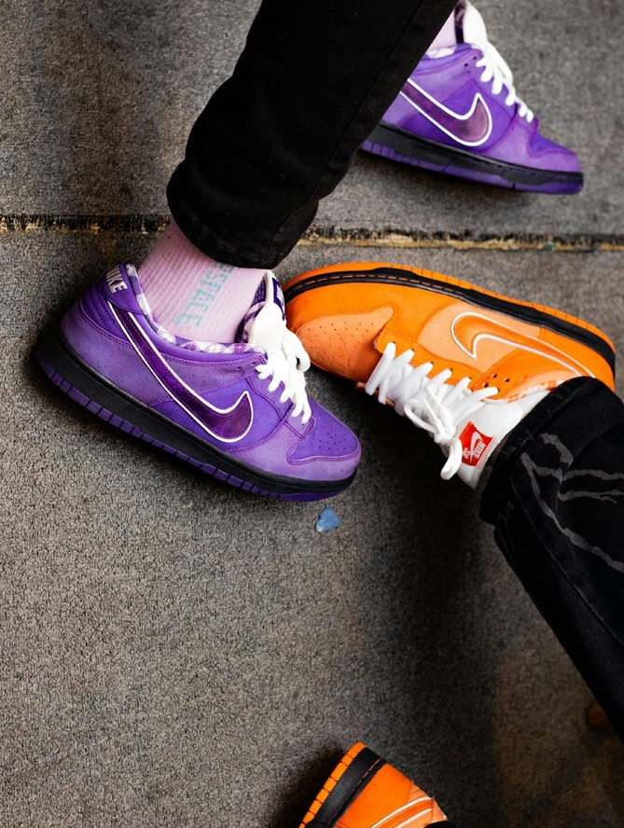

Pexels

deemed taboo to be addressed in ath-beauty, alongside inclusive solutions that leave no- one underserved. Conversations around uncomfortable body issues non-exclusive to athletes, such as sweat, hyperhidrosis and chafing, are being normalized and prompting brands to create solutions for these problems.



Pexels

**/ Sports as means to connection**

Amid an attention recession and a loneliness epidemic, fostering social ties is a key way to make an impact and evoke a sense of belonging with consumers. In the US, [92%](https://www.tintup.com/blog/new-research-5-things-gen-z-wants-from-online-brand-communities/#%3A~%3Atext%3DOur%20study%20found%3A%2Ccommunities%20to%20shape%20brand%20opinion) of Gen Z say a brand’s community will influence their opinion of that brand, and [74%](https://www.tintup.com/blog/new-research-what-consumers-want-in-online-brand-communities/) say they are more likely to write a product review for a brand with a community. As consumers turn away from online content in favour of IRL interactions, brands will need to meet sports fans in social hubs IRL.

**Brand spotlight: Adidas**

Adidas and the Jamaica National Teams have launched four new pieces designed by Grace Wales Bonner, including home and away kits, a pre-match shirt and a reversible anthem jacket

 SECTION 4: DO IT FOR THE TREND E-COMMERCE REINVENTED 36



TikTok Shop

TREND 02 THE RISE OF SPORTS FANDOMS

##### How can TikTok Shop turn Trend into Action?

Traditional live sports viewership is declining among Gen Z, as they have a [strong preference](https://www.sportspro.com/news/sports-fans-gen-z-millennial-content-consumption-social-media-deloitte/) for consuming sports content through

**Case Study: Free Soul**

[Free Soul](https://www.tiktok.com/%40freesoul?lang=en), renowned for its innovative range of products targeting women’s unique nutritional needs, combines superfoods, micronutrients, and adaptogens to create empowering, effective solutions.

Free Soul made a splash on TikTok Shop with a game-changing Super Brand Day. By blending exclusive bundles, irresistible discounts, and high-energy challenges, the brand kept the TikTok community hooked and eager to shop. Dynamic LIVE sessions and creative short-form content added

to the buzz, creating a wellness-centered experience that resonated deeply with fans.

Behind the scenes, Free Soul’s strategy focused on immersion, crafting moments that felt personal and empowering. The results? A staggering 490% uplift in GMV, proving their bold approach not only captured attention but also drove serious results. FreeSoul’s Super Brand Day wasn’t just a campaign—it was a masterclass in connecting and converting.

digital platforms. With that, brands have an opportunity to authentically interact with this passionate audience.

TikTok Shop’s livestream shopping feature allows brands to engage with sports fans in real time through interactive experiences. Hosting live sessions during major sporting events to showcase exclusive merchandise, behind-

the-scenes content, or athlete collaborations builds a deeper bond with fans while boosting immediate sales. With over [5,000](https://www.thetimes.com/business-money/companies/article/tiktok-dreams-of-bright-christmas-amid-live-shopping-boom-c2psdw80v) livestream shopping events occurring daily in the UK, this format reflects a growing consumer appetite for interactive commerce.

By diving into the buzzing community of #SportsTok, brands can seamlessly integrate into the vibrant sports culture thriving on the platform, which can surface engaging content to millions of users globally.

 SECTION 4: DO IT FOR THE TREND E-COMMERCE REINVENTED 37

##### Brand Takeaways

TREND 02 THE RISE OF SPORTS FANDOMS

1. **Celebrate Inclusivity through Sports**

Harness the power of athletic beauty by collaborating with athletes and fitness influencers with diverse backgrounds, bodies and styles. This approach not only broadens your audience - it also strengthens your brand’s cultural relevance, and unites individuals around common values while driving growth.

To help with that, TikTok Shop’s affiliate program and integrated content tracking offer a transparent attribution model, giving brands clear insights into the sources of their sales.

1. **Offer Cool Currency**

Tap into sports fandoms by offering merchandise that reflects consumers’ deep knowledge of niche sports teams or that provides playful commentary on current sports events. For example, [Rihanna’s Savage x Fenty](https://www.vogue.com/article/rihanna-savage-fenty-super-bowl-collection) [limited edition t-shirt for Superbowl LVII](https://www.vogue.com/article/rihanna-savage-fenty-super-bowl-collection), which humorously read, “Rihanna concert interrupted by football game, weird but whatever,” resonated with fans by blending cultural references with entertainment value.

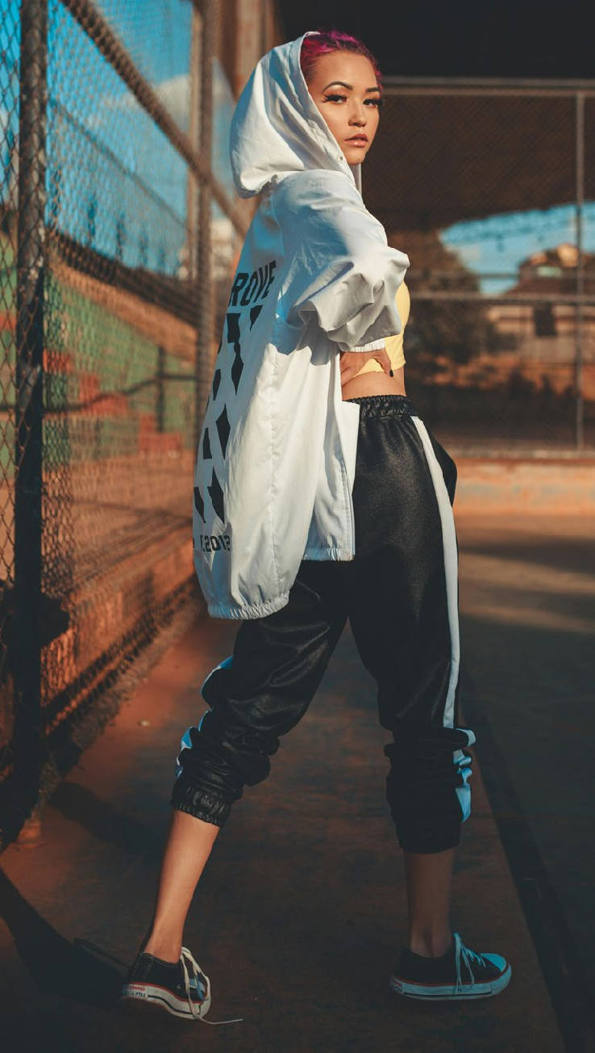

Pexels

Products tied to trending cultural moments and memes have the potential to go viral, driving immediate engagement. TikTok Shop enhances this momentum by turning interest into instant sales through its seamless integration of product discovery and purchase. By staying culturally attuned, brands can create timely, buzzworthy products.





 SECTION 4: DO IT FOR THE TREND E-COMMERCE REINVENTED 38

#### Nuanced Glimmers

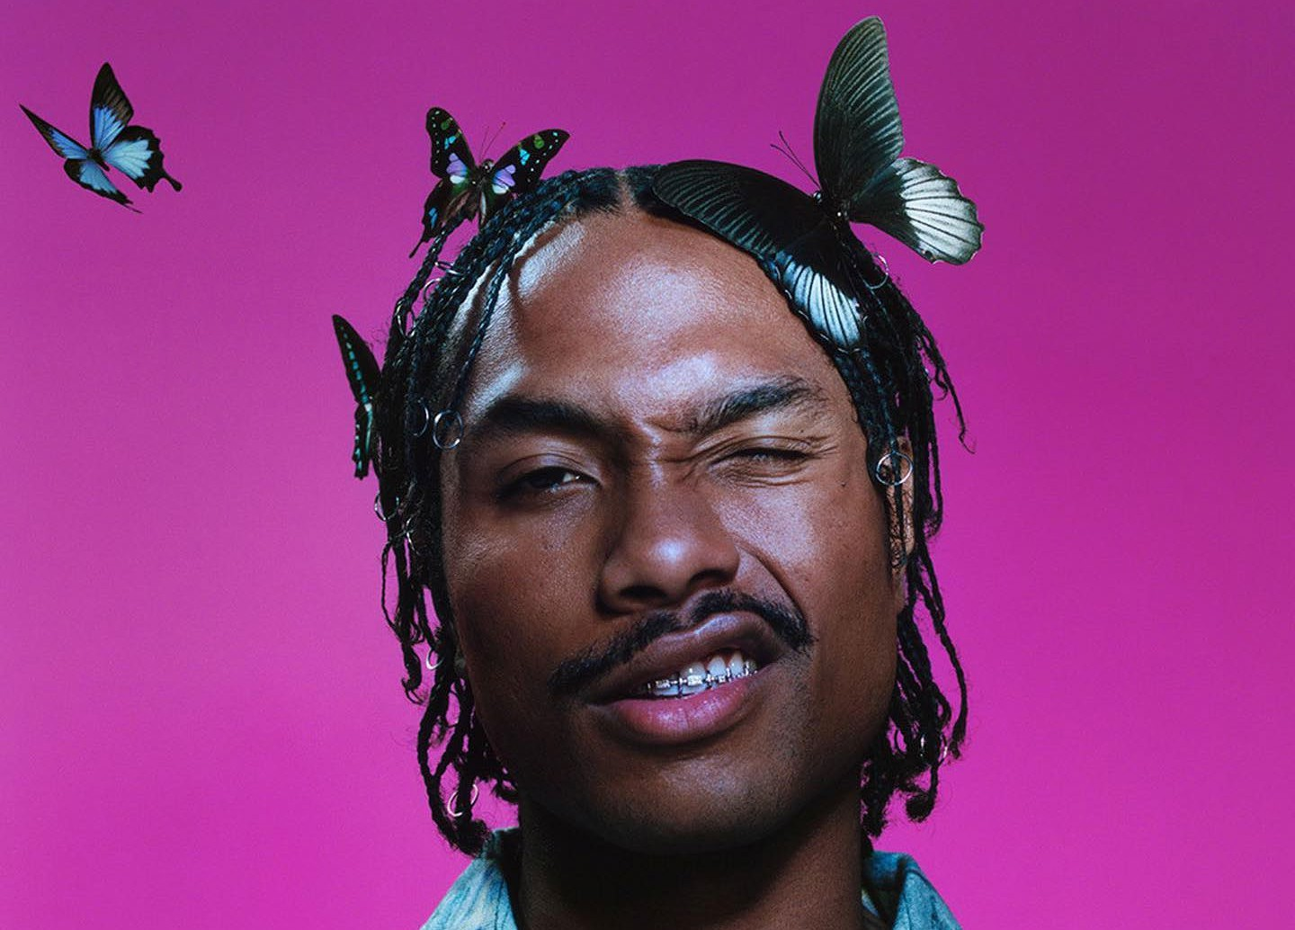

Deathtostock

###### Glimmers are micro-moments of joy, comfort and safety. They will become a vital coping tool for consumers weathering a global polycrisis and what feels like a darkening future.

 SECTION 4: DO IT FOR THE TREND E-COMMERCE REINVENTED 39



##### What is the context?

TREND 03 NUANCED GLIMMERSS

Glimmers are small, uplifting moments of positivity, joy or contentment – it could be hearing your favourite song, or meeting a friendly dog on your morning walk. These simple, personal and inherently achievable pleasures serve as a powerful antidote to the stress and burnout of challenging times, offering comfort and motivation. They are the opposite of triggers (an emotional reaction to a disturbing topic such as violence or prejudice), and a

vital coping mechanism amid global crises, the loneliness epidemic and widespread burnout.

Psychotherapist Lee Phillips notes that these micro-moments can uplift moods and inspire people to pursue their goals.

Though deeply personal, the appeal of glimmers lies in their universal resonance. They are closely tied to social interactions, such as sharing a laugh or a kind gesture, which foster belonging and strengthen bonds. These positive experiences activate the parasympathetic nervous system, enhancing relaxation and emotional well-being. By savoring glimmers, individuals can improve social connections and mental health, creating a stronger sense

of community.

A survey with over 3,000 respondents from the UK, US and China found that:

%

61

of them wanted brands to

make them feel deep emotions

63

%

wanted multi-sensory experiences.

Wunderman Thompson, 2023

**Twice as many consumers say** they shop from brands that elicit certain emotions, whether joy (49%) or delight (45%), compared with brands that just sell (26%).

VML, 2023

Skincare brand Bubble collaborated with Disney’s Inside Out 2 movie and released limited-edition products with a social campaign that tied personal emotions to skincare routines. The TikTok campaign spotlighted each product and its correlating emotion

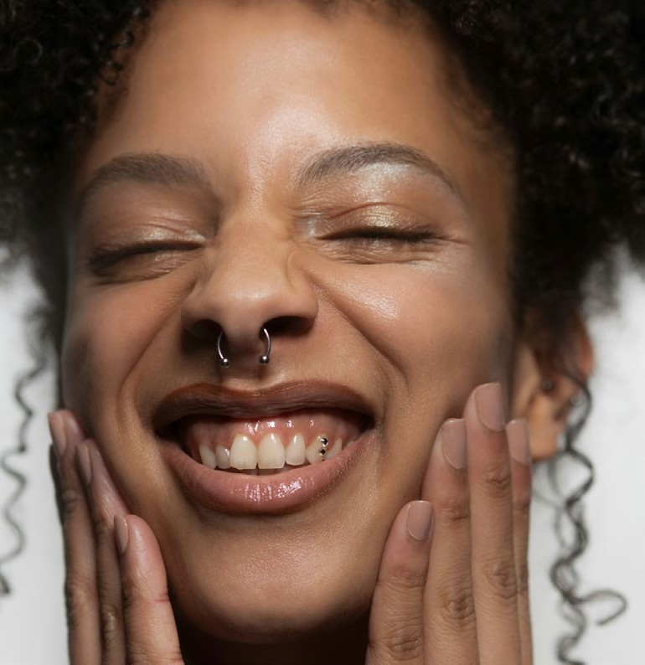

Deathtostock

“People are yearning for emotion- inducing experiences that deliver feelings of joy and wonder, craving the spectacular, the surreal, and the otherworldly.”

Marie Stafford, Global Director, Wunderman Thompson Intelligence, [2023](https://www.vml.com/insight/the-age-of-re-enchantment-report)

 SECTION 4: DO IT FOR THE TREND E-COMMERCE REINVENTED 40

TREND 03 NUANCED GLIMMERSS

##### How is the trend expressed?



Pexels

**Brand spotlight: Loewe**

Despite being a luxury fashion house, Loewe’s TikTok account is punctuated with playful and comedic content that leverages creators from the platform like The Rosenthals and Izzi Poopi, as well as taking part in platform trends like ‘real or cake’ with blatantly obvious answers to advertise its handbags

**/ Multisensorial and tactile hedonism**

With so much time spent online, consumers will want things that engage their emotions – even the darker ones – and ignite all their senses: touch, taste, scent, sight, sound, and the sixth sense. They are seeking products that can provoke feelings of awe and wonder - look out for the rise of tactile hedonism, characterised by plush, sensual and stimulating products and materials. Incorporating tactility as therapy across form, materials and packaging will especially appeal to glimmer-seekers.

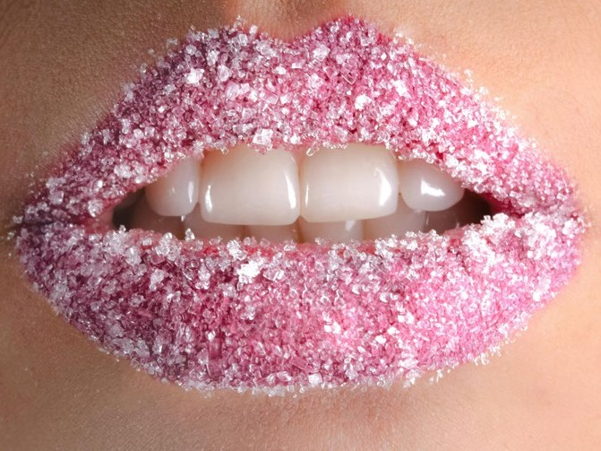

Pexels

**/ Sentimental items**

Treat culture will continue to drive purchases - especially in beauty -,

offering joy and relief to consumers affected by life’s challenging moments. As an evolution of the [lipstick effect,](https://www.forbes.com/sites/pamdanziger/2022/06/01/with-inflation-rising-the-lipstick-effect-kicks-in-and-lipstick-sales-rise/) this expression reflects a preference for affordable luxuries and small items - like lip balms, water bottles and stuffed toys - that can represent a source

**Brand spotlight: Jellycat**

Cult favourite plush toy company Jellycat has capitalised on TikTok’s ‘emotional support plushie’ trend and has opened various

pop-up activations worldwide. The brand created a campaign on TikTok that featured CGI depictions of its characters and encouraged customers to visit its themed pop-ups to buy the collectible toys

of comfort and reassurance for everyday life, like a safety blanket.

 SECTION 4: DO IT FOR THE TREND E-COMMERCE REINVENTED 41

**Brand spotlight: Rhode**

Skincare brand Rhode leaned into the growing interest in miniatures on TikTok for its campaign promoting new pocket-size blushes



TREND 03 NUANCED GLIMMERSS

**/ The Kidult Consumer**

When adulthood has become synonymous with stress, putting playtime first is a serious matter. Kidults are consumers that are looking to incorporate more play into adulthood. This

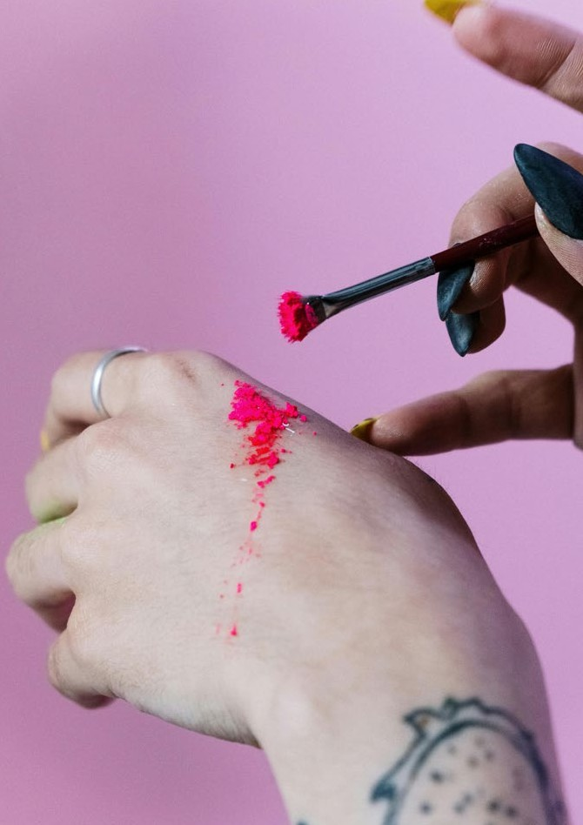

Pexels



behavior is different from escapism or nostalgia; they aren’t interested in returning to childhood. Instead, they’re rethinking what it means to be an adult, and looking forward to a long-term lifestyle that is fun, silly and exciting.

**/ Offbeat humour**

Consumers are increasingly turning to light- hearted humor as a way to navigate life’s pressures, actively seeking content that delivers immediate stress relief. By engaging with playful moments on social media, individuals can counterbalance daily challenges and foster

a more positive outlook. This trend extends to brand interactions, with one global survey

revealing that 91% of consumers prefer brands to be funny.

Pexels

**Brand spotlight: Laneige**

Skincare brand Laneige has incorporated the concept of sentimental items into its influencer partnerships and social media copy on TikTok, promoting its lip balms as the ultimate emotional support essential

 SECTION 4: DO IT FOR THE TREND E-COMMERCE REINVENTED 42

TREND 03 NUANCED GLIMMERSS

##### How can TikTok Shop turn Trend into Action?



TikTok Shop

By aligning with this emotional undercurrent, brands can create content that resonates deeply with TikTok’s primarily Gen Z and Millennial users, who are seeking

**Case Study: Coca-Cola Happy Tears**

Coca-Cola’s Happy Tears Zero Sugar, launched exclusively on TikTok Shop in 2024, celebrated Random Acts of Kindness Day with limited- edition “hype kits” featuring two cans—one to keep, one to share—and branded merchandise. The thoughtful approach invited consumers to spread kindness and foster community through shared experiences.

Aligning perfectly with the Glimmers trend, Happy Tears tapped into the power of small, uplifting moments to resonate with audiences during challenging times. By promoting acts of kindness and celebrating joy, Coca-Cola created a campaign that reflected a universal

desire for positivity and connection while subtly enhancing emotional well-being.

TikTok Shop played a central role in the campaign’s success, connecting Coca-Cola with a digitally native, Gen Z audience.

Through exclusive content, influencer collaborations, and TikTok’s interactive features, the brand seamlessly integrated into the platform’s culture, driving engagement and strengthening consumer connections.

positivity and meaningful distraction amid global challenges. Through TikTok, brands can meet the audience’s desire for entertainment and emotional connection.

Fashion and beauty brands, in particular, can capitalize on the Glimmers trend by leveraging TikTok Shop tools such as livestreams, user-generated content (UGC), gamification, and exclusive offers. For example, a beauty brand might host a livestream showcasing limited-edition products in soothing or joyful hues, weaving uplifting narratives into the presentation. Similarly, brands can encourage UGC campaigns that celebrate small, joyful

rituals—like getting ready for an evening out—that resonate with the Glimmers theme.

These strategies create unexpected and delightful moments that not only engage consumers but also fulfill their emotional needs, turning shopping into an uplifting communal experience.

By weaving community-building and storytelling into their TikTok Shop strategies, brands can foster a sense of connection and joy. From shared laughter during live sessions to the thrill of exclusive deals, TikTok Shop empowers brands to inspire, uplift, and deliver Glimmers of positivity to their audience.

 SECTION 4: DO IT FOR THE TREND E-COMMERCE REINVENTED 43

TREND 03 NUANCED GLIMMERSS

##### Brand Takeaways

1. **Offer “Feel-Good” Experiences Online**

Offer joyful, feel-good moments that resonate with audiences and connect like-minded individuals with each other and with your brand. These micro-moments of surprise

and delight are perfect for TikTok Shop, where commerce meets entertainment and emotional engagement.

Host a “Random Acts of Kindness” livestream where purchases fund surprises or charitable donations, tying sales to shared positivity.

Team up with creators known for humor or heartwarming content to showcase products in surprise gifting and comedic unboxings,

or explore different senses with ASMR and texture. Launch a challenge encouraging users to share their glimmers—small wins or delightful moments—using duet or stitch features to spark waves of uplifting, brand- linked content.

1. **Lean Into Play**

Rethink your products and content with whimsy in mind, leveraging the growing movements

of Kidults, nostalgia and sentimental items. Create social content that features miniature characters and scaled-down items, all geared towards grown-ups. Turn functionality into fun and incorporate toy-like elements into your products - in the UK, toy sales to kidults rose by [6%](https://www.bbc.com/news/business-68100465) last year, bucking the 5% downturn in toy sales as a whole in the region.

Create an opportunity for co-creation with AR filters on TikTok, where kidults can virtually test products and create user-generated content promoting your brand, motivating others to do the same.



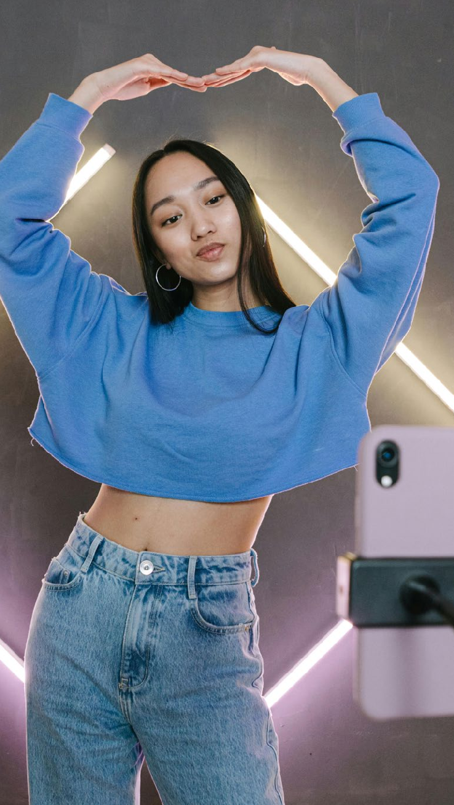

Pexels

 SECTION 5: FROM VIEWS TO BUYS E-COMMERCE REINVENTED 44

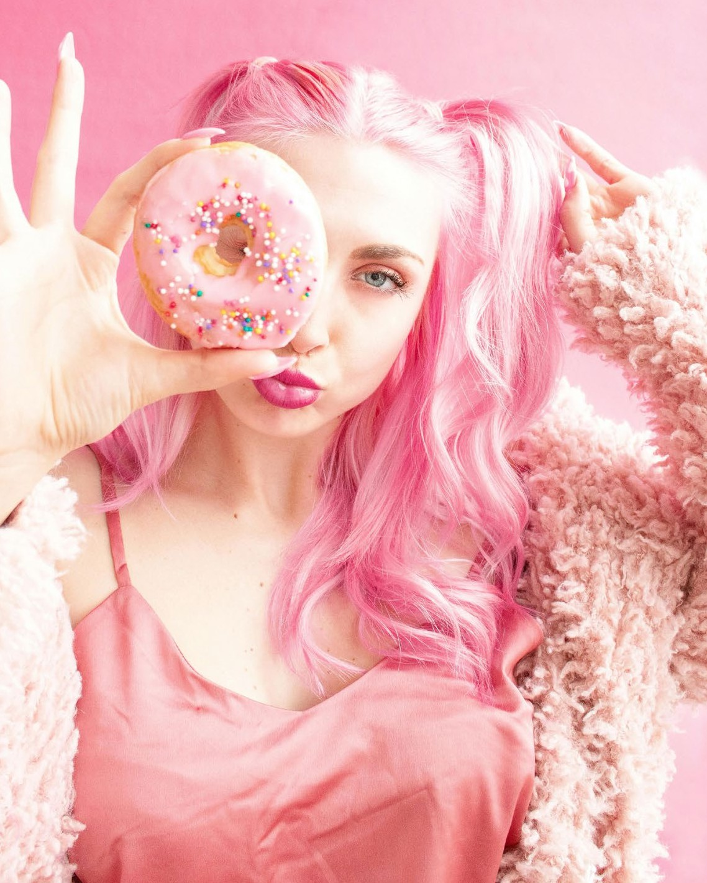

# From Views To Buys

#### Leverage the Best of TikTok Shop



Pexels

 SECTION 5: FROM VIEWS TO BUYS E-COMMERCE REINVENTED 45

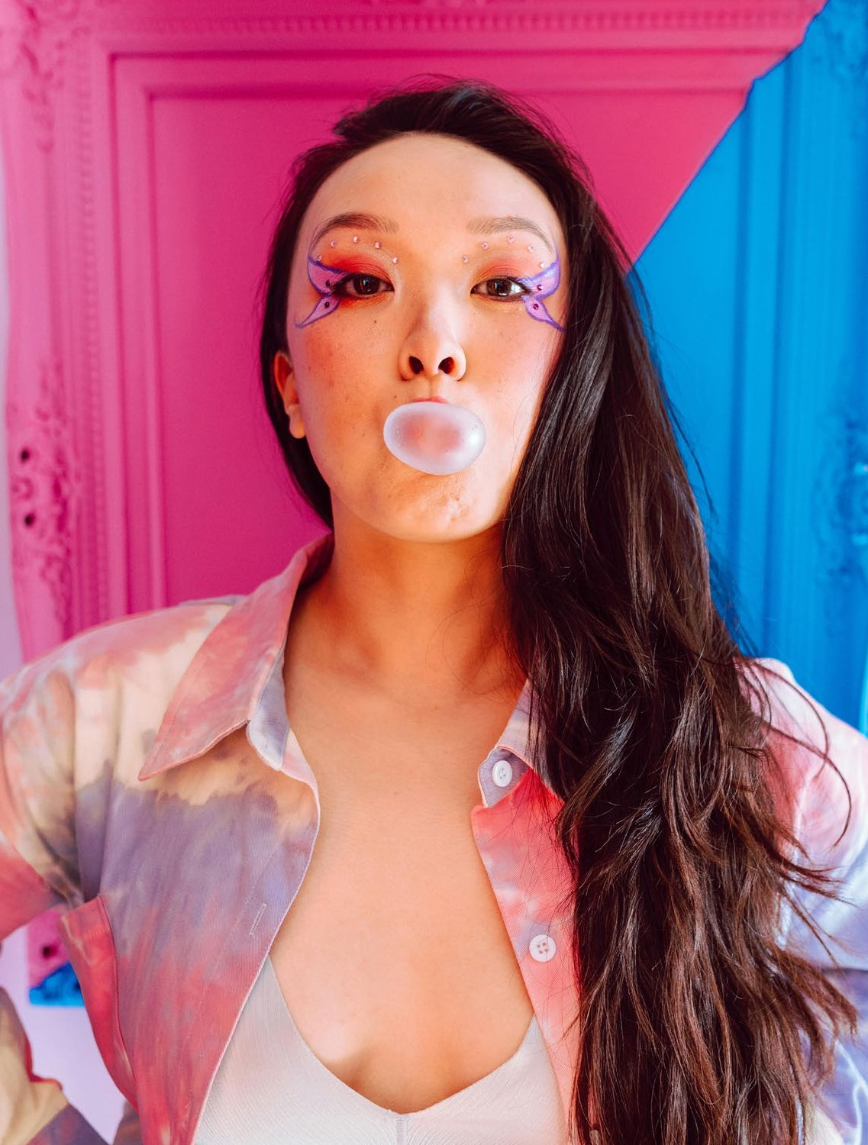

With TikTok Shop, embrace the new era of discovery commerce and reach vast, engaged audiences through social shopping formats that are couched in

entertainment, discovery and authenticity.

With thoughtfully designed and integrated features and tools that aid merchants from discovery, content creation, conversion and fulfilment, merchants will be able to navigate and leverage all that the platform has to offer and supercharge growth.

Pexels

TIKTOK SHOP x WGSN E-COMMERCE REINVENTED 46

### TikTok Shop: Discovery, Creation, Conversion, Fulfilment

Shop Ads

TikTok Shop Ads enable businesses to promote their products within the app, allowing customers to discover and purchase items directly. This advertising tool helps target specific audiences, increasing the likelihood of

Shop Tab

The dedicated Shop Tab allows businesses to display their products in a marketplace where customers can search, discover promotions, and manage orders. This centralized shopping hub increases product visibility and streamlines the

Product Showcase

Companies can curate personalized product collections on their profiles, displaying organized product tiles with detailed descriptions and customer reviews. This feature helps potential customers easily find and evaluate products, facilitating informed

Discovery

engagement and conversion.

purchasing process.

purchasing decisions.

Fulfilment

Affiliate Program

By connecting with creators through commission-based product marketing opportunities, businesses can expand their reach. Creators promote products in their content, earning commissions on sales, which can enhance brand awareness and drive sales through authentic endorsements.

LIVE Shopping

Businesses can tag products directly in their videos and live streams, allowing users to purchase items seamlessly without leaving the app.

This integration enhances the shopping experience and can lead to higher conversion rates.

Fulfilled By TikTok

This logistics solution allows businesses to focus on product development while TikTok handles storage, picking, packing, and shipping. By ensuring efficient order fulfillment, companies can enhance customer satisfaction and encourage repeat purchases.



TikTok Shop Partners

TikTok Shop Partners are specialized service providers that equip merchants with everything from content creation, shop operations, to growth strategies. For brands looking to establish a presence on TikTok Shop, they offer informed, proven guidance tailored to every need, providing support across merchant development and management content creation and e-commerce strategy.

Merchants can also work with their Shop partner to find creators that align with their brand.

TIKTOK SHOP x WGSN E-COMMERCE REINVENTED 47

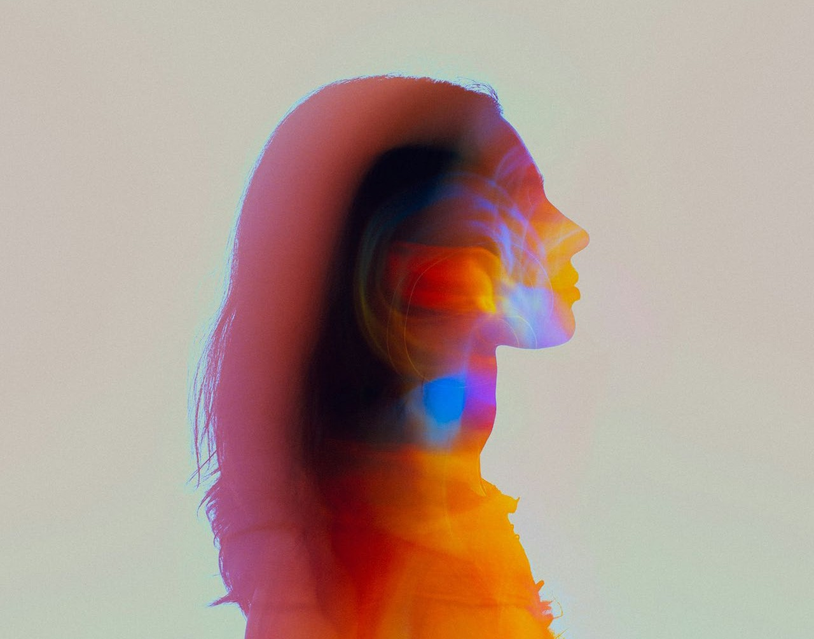

WGSN is the world’s leading trend forecaster

Pexels

##### WGSN Mindset Consultancy

We create a vision of near, mid and far futures to show our clients the multiple possible outcomes that will shape consumers & businesses, on a macro to micro level.

Our unique Mindset consultancy proposition does this through quantitative and qualitative insights, layered with our trend

& future focused outlook to provide you with strategic recommendations targeted to your future business objectives.

Deathtostock

TIKTOK SHOP x WGSN E-COMMERCE REINVENTED 48

### Our tools



WGSN’s research methodology allows us to identify the signals of change and evaluate, verify and forecast trends.

We don’t just track the past and extrapolate it into the future, we actively forecast the future influences on the

consumer, product design and trading through a sustainable lens, now and in the years to come.



**25 years** of forecasting expertise. Covering 38 cities across six continents that are tracked for deep local insight

**Over 10,000** brands tracked across over 200 retailers

**Over 5 years** of search history across retailer websites and search engines

**Over 5 million** attributed catwalk images

**150+** monthly trend reports

**Over 100,000** social media posts tracked monthly through image recognition technology

**Expert network** of forecasters, industry specialists,creatives, locals

**Bridging trends** to different businesses across industries, borders & audiences

**Signal assessment** that enable the identification of trends and their meaning wand impact on our clients’ businesses